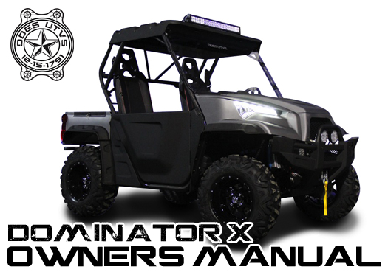

WARNING
● Operation of this UTV by anyone under the age of 16 may increase the risk of severe injury or death!!! This vehicle can roll if not driven properly!!!
● Adult supervision is always required.
● Anyone under the age of 16 may NOT operate this UTV.
● Overloading the UTV may adversely affect the handling of this vehicle.
● Operator use only, excess passengers prohibited.
● This vehicle is designed and manufactured for OFF-ROAD use only.
● Driving Off Road Vehicles on public streets, roads, or highways is illegal.
● All Riders MUST wear helmet and other protective equipment.
● Do NOT operate this vehicle during/after consuming Alcohol or Drugs.
● Don’t do drugs. It’s not healthy for you.
● When refueling, you must shut off the engine to avoid spark or fire risk.
● Read owner's manual carefully before operating this vehicle.
INTRODUCTION
Dear Valued ODES Customer,

Congratulations and thank you for choosing to become a part of our ODES family with the purchase of your new ODES UTV. We have designed this vehicle with you, the customer, in mind, providing you with great power, stability, and functionality with your UTV. This UTV was designed for OFF Road use only.

This Operator’s Manual is here to familiarize any operators of all proper operating procedures. It also includes important and required information about the general care and maintenance of your ODES UTV.

Read the following pages regarding safety warnings, active riding skills, and precautions for your own safety and the safety of others around you. Children and adults have different skill levels, physical abilities, and use of judgment. Anyone under the age of 16 is NOT permitted to drive this vehicle. Parents should always supervise their child’s (anyone under 16) use of this UTV at all times.

All information in this manual is based on the latest product data and specifications available at the time of printing. ODES, the Manufacture of this UTV, reserve the right to make product changes and improvements, which may effect the illustrations, layout, or explanations without notice.

If you have any other questions regarding our UTV’s operation or maintenance, please contact any authorized dealer.

Product and specifications are subject to change without notice.

Table of Contents
PAY ATTENTION TO YOUR SAFETY································································ |  |  |  | 10
TIPS FOR SAFE DRIVING·············································································· |  |  |  | 13
INTRODUCTION··························································································· |  |  |  | 14
IMPORTANT MANUAL INFORMATION······························································ |  |  |  | 15
IMPORTANT NOTICE···················································································· |  |  |  | 16
HOW TO IDENTIFY YOUR UTV······································································· |  |  |  | 17
 | Engine and Vehicle Identification Number Location········································· |  |  | 18
 | Location of the warning and specification labels············································· |  |  | 19
SAFETY INFORMATION················································································· |  |  |  | 25
DESCRIPTION AND VEHICLE IDENTIFICATION················································ |  |  |  | 31
CONTROL FUNCTIONS················································································· |  |  |  | 33
 | Key switch····························································································· |  |  | 33
 | Switches································································································ |  |  | 34
 |  |  | On–Command four-wheel drive and differential gear lock switches············ | 35
 | Indicators & Display················································································· |  |  | 36
 |  |  | Odometer······················································································ | 37
 |  |  | Functions switch············································································· | 37
 |  |  | Km/h & mph mode change································································ | 38
 |  |  | Other indicator lights········································································ | 38
 |  |  | Gas pedal······················································································ | 40
 | Brake pedal···························································································· |  |  | 41
 | Parking brake lever·················································································· |  |  | 41
 | Drive select lever····················································································· |  |  | 42
 | Fuel tank cap·························································································· |  |  | 43
 | Seats···································································································· |  |  | 43
 | Seat belts······························································································ |  |  | 44
 | Glove compartment·················································································· |  |  | 46
 | Cargo bed······························································································ |  |  | 47
 | Opening and closing the tailgate································································· |  |  | 47
 | Lifting and lowering the cargo bed······························································· |  |  | 48
 |  |  | Trailer hitch bracket········································································· | 50
 |  |  | Safe driving precautions··································································· | 57
 | Gear Shift Adjustment··············································································· |  |  | 62
 | Auxiliary DC jack····················································································· |  |  | 63
PRE-OPERATION CHECKS············································································ |  |  |  | 65
 | Front and rear brakes··············································································· |  |  | 65
 |  |  | Brake fluid leakage·········································································· | 65
 |  |  | Brake operation·············································································· | 65
 | Fuel······································································································ |  |  | 66
 |  |  | Gasoline Type················································································ | 67
 |  |  | Accelerator pedal············································································ | 68
 | Seat belts······························································································ |  |  | 68
 | Steering································································································· |  |  | 68
 | Fittings and fasteners··············································································· |  |  | 68
 | Lights···································································································· |  |  | 68
 | Switches································································································ |  |  | 69
 | Tires····································································································· |  |  | 69
OPERATION································································································ |  |  |  | 72
 | Jump-starting·························································································· |  |  | 72
 | Warming up···························································································· |  |  | 74
 |  |  | Shifting: Neutral to Reverse······························································· | 74
 |  |  | Engine break-in·············································································· | 76
 | Parking································································································· |  |  | 77
 | Parking on a slope··················································································· |  |  | 77
 | Accessories and loading··········································································· |  |  | 78
 |  |  | Accessories··················································································· | 78
 |  |  | Loading························································································· | 79
DRIVING YOUR VEHICLE·············································································· |  |  |  | 81
 | Getting to know your vehicle······································································ |  |  | 81
 | Turning your vehicle················································································· |  |  | 84
 | Braking································································································· |  |  | 85
 | Going uphill···························································································· |  |  | 85
 | Going downhill························································································ |  |  | 87
 | Crossing through shallow water·································································· |  |  | 89
 | Riding over rough terrain··········································································· |  |  | 90
 | Riding in brush or wooded areas·································································· |  |  | 91
 | Encountering obstacles on the trail······························································ |  |  | 91
PERIODIC MAINTENANCE············································································· |  |  |  | 92
 | Periodic maintenance/lubrication································································ |  |  | 93
 | Hood····································································································· |  |  | 95
 |  |  | To open························································································· | 95
 |  |  | To close························································································ | 95
 | Console································································································· |  |  | 96
 |  |  | To install························································································ | 96
 | Changing Oil·························································································· |  |  | 96
 | Rear knuckle upper and lower pivot lubrication··············································· |  |  | 97
 | Steering shaft lubrication··········································································· |  |  | 98
 | Wheel removal························································································ |  |  | 98
 |  |  | Wheel installation············································································ | 99
 |  |  | Battery·························································································· | 100
 |  |  | Battery maintenance········································································ | 101
 |  |  | Recommended Fuses······································································ | 103
 |  |  | Tail/brake light bulb replacement························································· | 103
 |  |  | Troubleshooting·············································································· | 105
 |  |  | Troubleshooting charts····································································· | 106
 | Engine overheating·················································································· |  |  | 107
Cleaning and storage············································································ |  |  |  | 109
 | CLEANING···························································································· |  |  | 109
 | STORAGE····························································································· |  |  | 111
NOISE REGULATION···················································································· |  |  |  | 113
ENGINE······································································································ |  |  |  | 114
 | Engine Oil······························································································ |  |  | 114
 | Engine Coolant······················································································· |  |  | 118
 | Air Filter································································································· |  |  | 121
 | Drive Belt······························································································· |  |  | 122
 | CVT Cover Drain Screw············································································ |  |  | 122
 |  |  | Valve Adjustment············································································ | 123
 |  |  | Gearbox Oil··················································································· | 124
MAINTENANCE CHART················································································· |  |  |  | 126
Fault codes·································································································· |  |  |  | 130
 |  | Read fault code······················································································ |  | 130
 |  | Clear fault code······················································································ |  | 131
Warranty Statement···················································································· |  |  |  | 132
SPECIFICATIONS························································································· |  |  |  | 135

PAY ATTENTION TO YOUR SAFETY
This section presents some of the most important information and recommendations to help you ride your UTV safely. Please read these pages. This section also includes information about the location of safety labels on your UTV.

Important safety information
Your UTV can provide many years of service and fun if you take responsibility
for your own safety, others around you, and understand the challenges you can meet while riding. Throughout this owner’s manual, you will find many helpful recommendations to protect yourself and others while riding. The following are some we consider most important.

Follow the age recommendation
The minimum recommended age of this UTV model is 16 years. Anyone under the age of 16 are NOT permitted to operate this vehicle.

Always wear a helmet
It is a proven fact that helmets significantly reduce the number and severity of head injuries and or death. So always wear protective head gear while operating this vehicle! We also recommend wearing protective boots, gloves, and other protective gear.

Off-road use only
Your UTV is designed for OFF-ROAD use only. The tires are not made for pavement, and the UTV does not meet the specifications required for use on public roads.

Take time to learn & practice
Even if you have ridden other UTVs, take the time to become familiar with your skills and get accustomed to the size and weight of this vehicle.
Because many accidents involve inexperienced or untrained riders, we recommend all riders to take a training course approved by the UTV safety institute.
Contact an authorized UTV dealer to find out about training courses near you.

Be alert for off-road hazards
The terrain can present a variety of challenges when you ride off-road. Continually “read” the terrain for unexpected turns, drop-offs, rocks, ruts, and other hazards. Always keep your speed low enough to allow time to see and react to hazards.

Ride within your limits

Pushing the limits is another major cause of UTV accidents. Never attempt to ride beyond your personal abilities or faster than conditions warrant.

Don’t drink and ride

Drinking and riding can also cause potentially fatal accidents. Do not operate this vehicle if you have consumed any alcohol. Just one drink can prohibit you from reacting in enough time to your changing surroundings.

Keep your UTV maintained
It is important to keep your UTV properly maintained and in safe riding condition. To help avoid having a breakdown, inspect your vehicle before each ride and keep it maintained. This unit comes with labels and a hangtag containing important safety information. Make sure anyone who rides this vehicle reads, and fully understands its contents before riding. These labels should be considered permanent parts of this UTV. If one comes off or becomes hard to read, contact an authorized dealer to have them replaced.

TIPS FOR SAFE DRIVING

1． Reduce speed when approaching any turns, hills, or bends. Once you have fully turned, gradually increase speed.
2． Be careful when passing any vehicle in front of you.
3． Check the brakes each time you ride to ensure they have not been cut during off-road riding or are too soft for full stopping capabilities.
4. During riding, the vibration can loosen the bolts. Before each ride, take time to inspect that all bolts are tightened.

For training please call ASI at 1-800-887-2887

INTRODUCTION

This manual will provide you with a basic understanding of the features and operation of this vehicle. It also includes basic maintenance and inspection procedures. If you have any questions regarding the operation or maintenance of your vehicle, please contact your dealer.

！WARNING
Please read this manual carefully before operating this vehicle. Do not attempt to operate this vehicle until you have attained adequate knowledge of its controls and operating features. Regular inspections and careful maintenance will help ensure that you safely enjoy the capabilities and reliability of this vehicle.

IMPORTANT MANUAL INFORMATION

FAILURE TO COMPLY WITH THE WARNINGS CONTAINED IN THIS MANUAL CAN RESULT IN SERIOUS INJURY OR DEATH.
Particularly important information is distinguished in this manual by the following notations:
! The Safety Alert Symbol means ATTENTION! BECOME ALERT!
YOUR SAFETY IS INVOLVED!

! WARNING: Failure to follow WARNING instructions could result in severe injury or death to the vehicle operator, a bystander or a person inspecting or repairing the vehicle.

CAUTION: CAUTION indicates special precautions that must be taken to avoid damage to the vehicle.

NOTE: NOTE provides key information to make procedures easier or clearer.

＊Product and specifications are subject to change without notice.

IMPORTANT NOTICE
● This vehicle is designed and manufactured for off-road use only. It is prohibited by the law to operate this vehicle on any public street, road, or highway.
● Check the laws and regulations in your state before choosing where to operate this vehicle. It is illegal to operate this vehicle on public lands where certain vehicle sizes are prohibited.
● This vehicle complies with most state off-highway noise level and spark arrester laws and regulations.

HOW TO IDENTIFY YOUR UTV

The main components of your vehicle are identified by different serial numbers. It may sometimes become necessary to locate these numbers for warranty purposes or to trace your vehicle in the event of it being lost or stolen. These numbers are required by the authorized UTV dealer to complete warranty claims properly. No warranty will be allowed by if the engine identification number (EIN) or vehicle identification number (VIN) is removed or manipulated in any way. We strongly recommend that you take note of all the serial/vin numbers on your vehicle and supply them to your insurance company.

Engine and Vehicle Identification Number Location

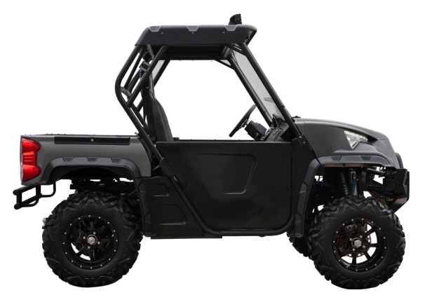

TYPICAL
1. EIN (Engine Identification Number on left side/under of the crankcase)
2. VIN (Vehicle Identification Number on right side/under of the frame)

LOCATION OF THE WARNING AND SPECIFICATION LABELS

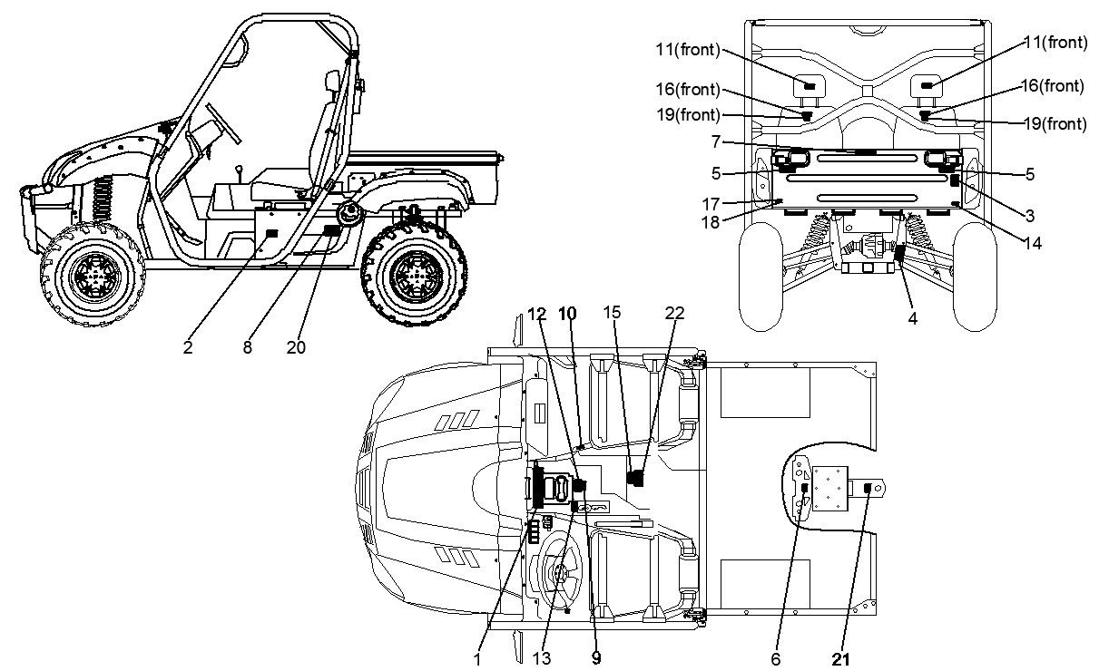

Read and understand all labels on your vehicle. They contain important operating and safety information. If any of them become lost or faded, contact your authorized dealer to have them replaced.

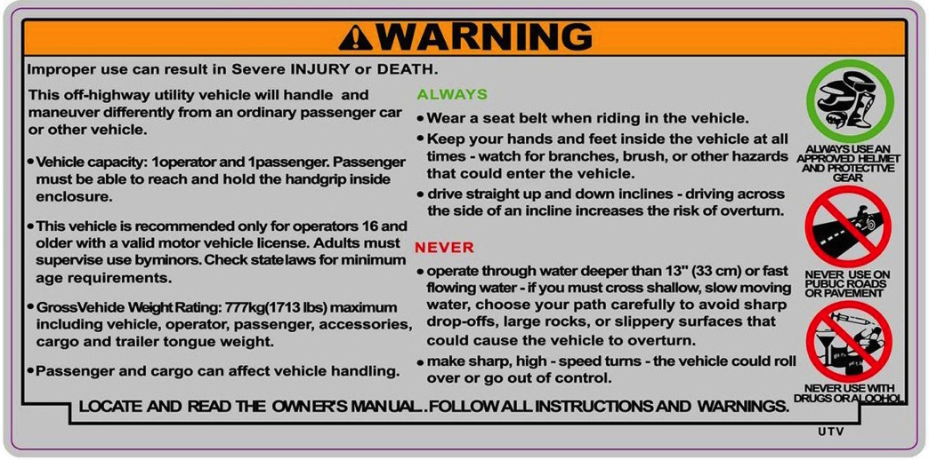

（1）

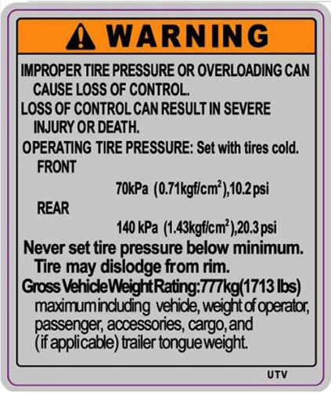
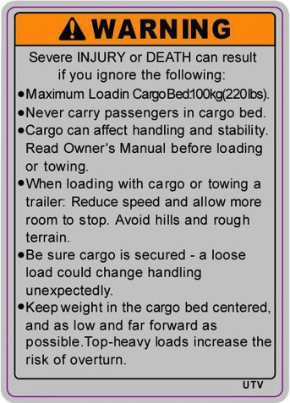
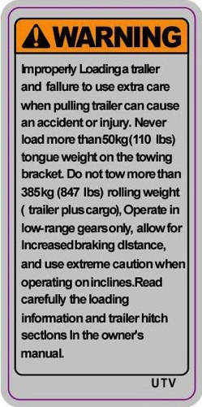

（2） （3） （4）
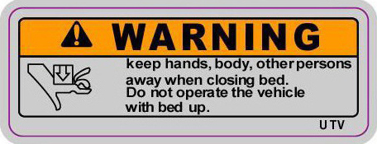
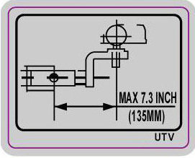

（5） （6）

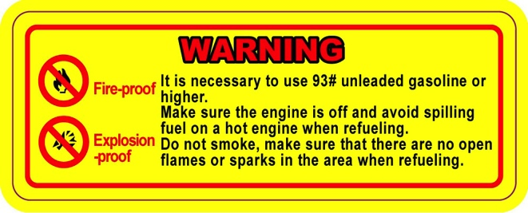
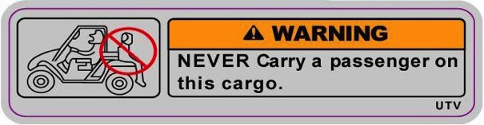

（7）
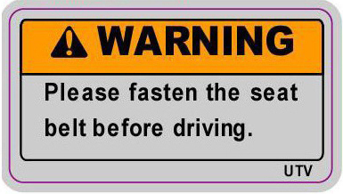
（8）
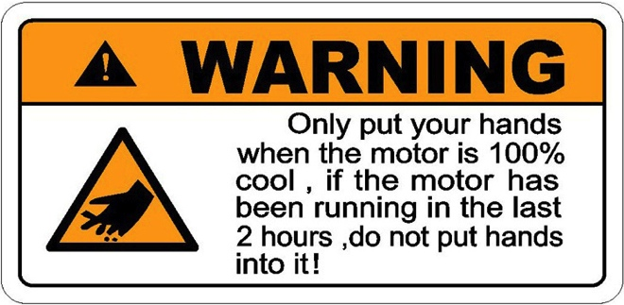

（9）
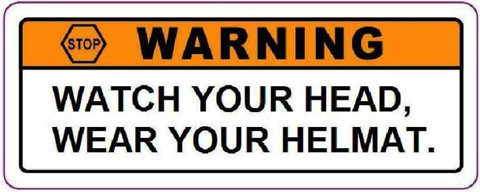

（10）

（11）
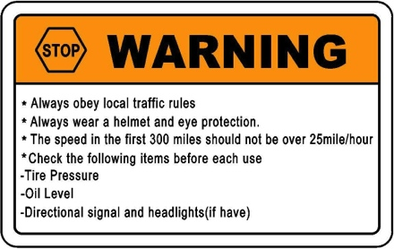
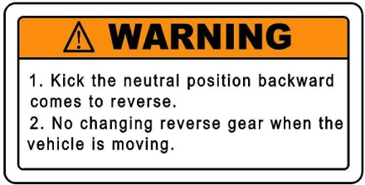

（13）
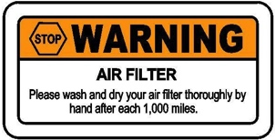
（12）

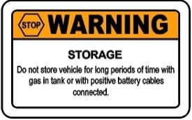
（15）

（14）

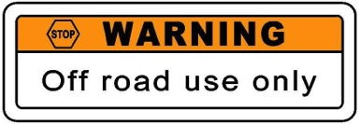
（17）

（16） （18）


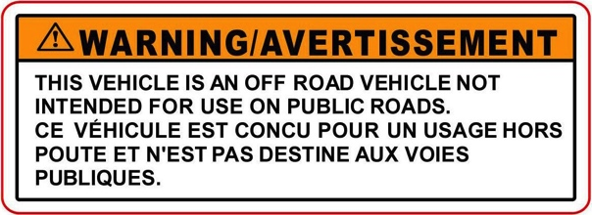
（19）

（20）

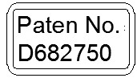
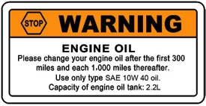

（21） （22）

SAFETY INFORMATION

This off-highway utility vehicle handles differently from other vehicles including
other UTVs, ATVs, Dune Buggies, Go Karts, or cars.
SEVERE INJURY OR DEATH can result if you do not follow these instructions:
● Read this manual and all labels carefully and follow ALL operating procedures.
● This vehicle is designed to carry one driver and one passenger ONLY! No one is to
be carried in the rear of the vehicle.
● Seat belts must be worn by driver and passenger at all times.
● If you cannot reach and hold the grip on the roll cage you may not ride this vehicle.
● Do not operate the vehicle on any paved surfaces, including sidewalks, driveways, parking lots, and streets.
● Never operate this vehicle on any public street, road, or highway, even a dirt or gravel street.
● Never operate this vehicle without wearing an approved motorcycle helmet that fits properly. You should also wear eye protection, gloves, sturdy boots, long-sleeved shirt or jacket, and long pants.
● Never consume alcohol or drugs before or while operating this vehicle.
● Never operate at speeds too fast for your skills or the conditions. Always go at a speed that is proper for the terrain, visibility, operating conditions, and your experience.
● Never attempt jumps or other stunts.
● Inspect your vehicle before each use to be sure it is in safe operating condition. Always follow the inspection and maintenance procedures and schedules described in this manual.
● Always keep both hands, arms, feet, and legs in side the vehicle at all times. Keep your feet on the floorboard. Never hold onto the roll cage except when using the handgrip inside the roll cage. Otherwise, your hand could be injured if it is caught between the roll cage and an obstacle outside the vehicle.
● Always keep both hands on the steering wheel when driving.
● Never wrap your thumbs and fingers around the steering wheel. This is particularly important when driving in rough terrain. The front wheels will move right and left as they respond to the terrain, and this movement will be felt in the steering wheel. A sudden jolt could turn the steering wheel around, and your thumbs or fingers

could be injured if they are in the way of the steering wheel spokes.
● Take extra caution when operating on unfamiliar terrain. Always be alert to changing terrain conditions when driving the vehicle.
● Never operate on excessively rough, slippery, or loose terrain until you have learned and practiced the skills necessary to control the vehicle on such terrain.
● Never turn at excessive speed. Practice turning at slow speeds before attempting to turn at faster speeds. Do not attempt turns on steep inclines.
● Never operate the vehicle on hills that are too steep for the UTV or for your abilities. Go straight up and down hills where possible. Maximum slope angle is 15°Degrees
● Never operate on hills that are slippery or ones where you will not be able to see far enough ahead of you. Never go over the top of a hill at fast speeds if you cannot see what is on the other side.
● Always follow proper procedures for going uphill. If you lose momentum and cannot continue up a hill, back down the hill with the engine in reverse gear. Use engine braking to help you go slowly. If necessary, use the brakes gradually to help you go slowly.
● Always check terrain carefully before going down hills. Go as slowly as possible. Never go down a hill at high speed.
● Always check for obstacles before operating in a new area.
● Never operate the vehicle in fast flowing water or water deeper than the floorboards on this model. Wet brakes may have reduced stopping ability. Test your brakes after leaving water. If necessary, apply them several times to let friction dry out the linings.
● Always be sure there are no obstacles or people behind you when you operate in reverse. When it is safe to proceed in reverse, go slowly. Do not brake abruptly when carrying loads in the cargo bed.
● Always use the size and type of tires specified in this manual.
● Always maintain proper tire pressure as described in this manual.
● Never exceed the stated load capacity. Cargo should be as far forward in the bed as possible, and distributed evenly from side to side. Be sure cargo is secured so that it cannot move around during operation. Reduce speed and follow instructions in this manual for carrying cargo or pulling a trailer. Allow greater distance for braking.

! WARNING
POTENTIAL HAZARD
Improper handling of gasoline.
WHAT CAN HAPPEN
Gasoline can catch fire and you could be burned or worse.
HOW TO AVOID THE HAZARD
Always turn off the engine when refueling. Do not refuel right after the engine has been running and is still very hot. Do not spill gasoline on the engine or exhaust pipe/muffler when refueling. Never refuel while smoking, or while in the vicinity of sparks, open flames, and clothes dryers. When transporting the vehicle in another vehicle, be sure it is kept in an upright position. Otherwise, fuel may leak out of the fuel tank. Other sources of ignition such as the pilot lights of water heaters can cause spark.
WHAT CAN HAPPEN
Gasoline is poisonous and can cause injuries.
HOW TO AVOID THE HAZARD
If you should swallow gasoline or inhale a lot of gasoline vapor, or get gasoline in your eyes, see your doctor immediately. If gasoline spills on your skin, wash with soap and water. If gasoline spills on your clothing, change your clothes.

! WARNING
POTENTIAL HAZARD
Starting or running the engine in a closed area.
WHAT CAN HAPPEN
Exhaust fumes are poisonous and may cause loss of consciousness and death within a short time .
HOW TO AVOID THE HAZARD
Always operate vehicle in an area
with adequate ventilation.

DESCRIPTION AND VEHICLE IDENTIFICATION

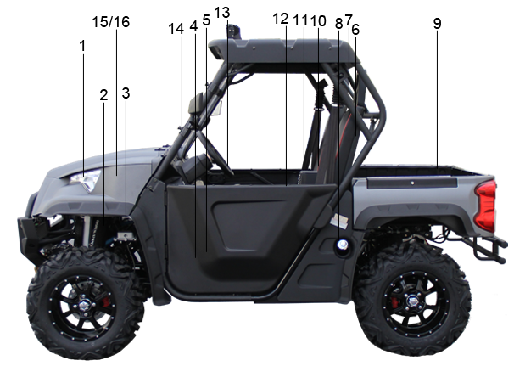

1. Headlights | 9. Cargo bed
2. Front shock absorber assembly adjusting ring | 10. Passenger seat
3. Brake fluid reservoir | 11. Passenger seat belt
4. Accelerator pedal | 12. Oil filter cartridge
5. Brake pedal | 13. Steering wheel
6. Driver seat | 14. Mains switch
7. Driver seat belt | 15. Battery
8. Fuel tank cap | 16. Fuses

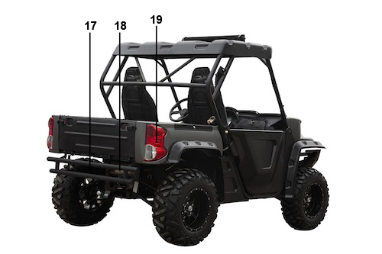
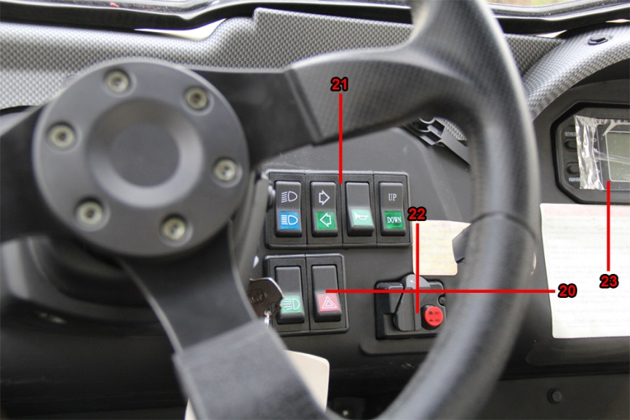

17. Rear shock absorber assembly adjusting ring | 20. Hazard warning light switch
18. Muffler | 21. Switches
19. Tail/brake lights | 22. 2WD-4WD switch
 | 23. Indicators & Display

NOTE:
The vehicle you have purchased may differ slightly from those shown in the figures of this manual.

CONTROL FUNCTIONS
Key switch

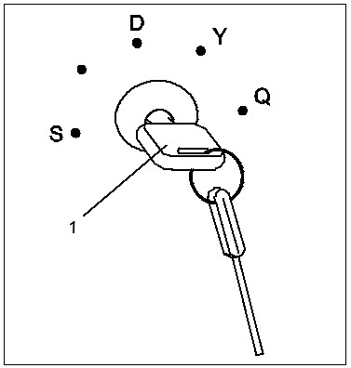

1. Main switch

Functions of the respective switch positions are as follows:
D:
All electrical circuits are supplied with power, the headlights and taillights come on when the light switch is on.
S:
All electrical circuits are switched off. The key can be removed from this position.
Q:
The electric starter is engaged by turning and holding the key in this position. Release the key when the engine starts.

CAUTION
Do not operate the electric starter
continuously for more than 5
seconds or starter damage could
occur. Wait at least 5 seconds
between each operation of the
electric starter to let it cool.
Do not turn the key to the “D”
position with the engine running or
damage to the electric starter can
result.
See starting instructions prior to
starting the engine.

Switches

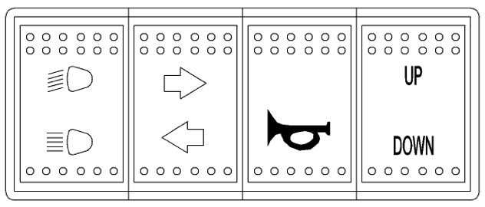

Light switch“/”
Set the switch to“ ”to turn on the low beam and the taillights.
Set the switch to“ ”to turn on the high beam and the taillights.

On–Command four-wheel drive and differential gear lock switches
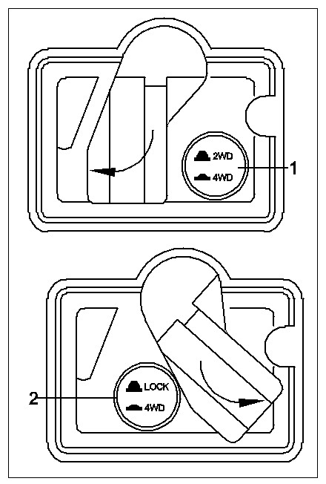

1. On-Command four-wheel-drive switch “2WD”/“4WD”
2. On-Command differential gear lock switch “4WD”/“LOCK”
This vehicle is equipped with an On-Command four-wheel-drive switch “2WD”/“4WD”and a differential gear lock switch “4WD”/“LOCK”. Select the appropriate drive according to terrain and conditions.

Indicators & Display

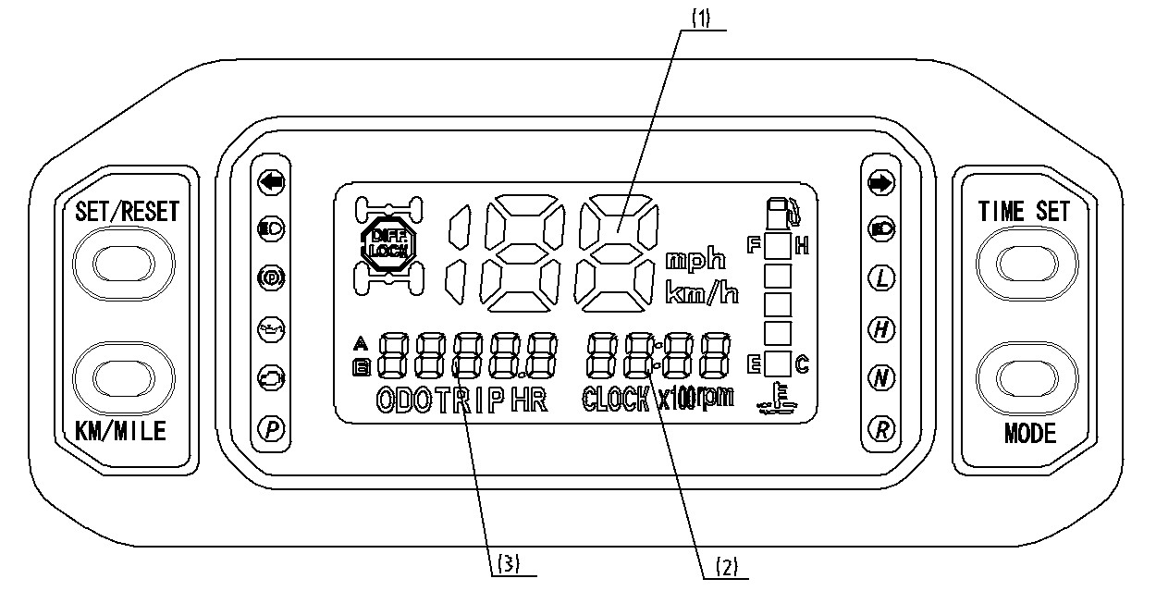

Odometer
When selected, the odometer registers total distance traveled in miles while the ignition is on A. To change the display from trip meter to odometer, press and release the Odometer/Trip meter select button.
Functions switch:
Press the MODE button. The modes of ODO, TRIP A, TRIP B, HRA and HRB will display in the odograph and be switched between. The figure of speed will display and update synchronous while switching between KM/H and MPH in unit of pedometer. By pressing “Time Set “, the user can set the hour and minute. Adjust hours or minutes by ascending or descending by continuing to press button of mode of “ Set/Reset” ,user can clean the record to zero for particular period of working mileage and time by pressing the mode of “Set/Reset “ while showing mode of
“TRIP A and HRA” in the speedometer.
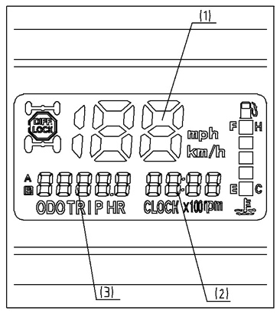
- Speed meter
- Time
- Trip meter

Km/h & mph mode change
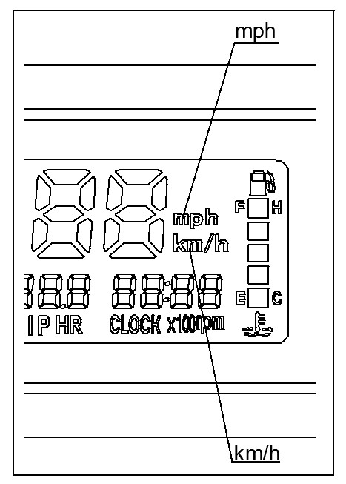
Press the MODE button; choose either Km/h or mph as needed.

Other indicator lights
Coolant temperature indicator light
“ ”
It indicates the temperature of coolant, if the temperature is above 102℃, stop engine immediately. Check coolant level and add if low. See authorized dealer if temperature indicator stays on and overflow tank is full of coolant.

Oil pressure indicator light “ ”
Indicates low/high oil pressure. When illuminated, see authorized dealer.

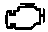
Check engine indicator light“ ”

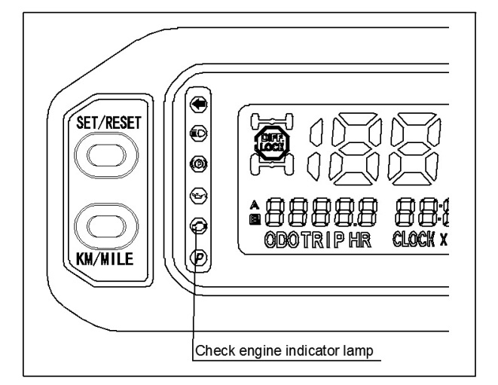

After turning the ignition switch on, the light shall be on, and the light shall be off after starting the engine. If the lamp is on while the engine is on, it indicates that the system has an error.

When some electric jet parts are reading faulty, check engine indicator light will also be ON, the vehicle still can be running, the driving performance will get worse, which reminds the driver to send the vehicle in for repair.

Gas pedal
Press the gas pedal down to increase engine speed. Spring pressure returns the pedal to the rest position when released. Always check that the gas pedal returns normally before starting the engine.
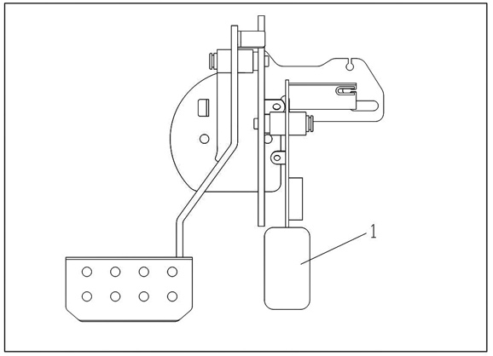

1. Accelerator pedal

Before starting the engine, check the gas pedal to be sure it is operating correctly. Make sure the gas pedal fully returns to the idle position as soon as it is released.
! WARNING
POTENTIAL HAZARD
Malfunction of the accelerator pedal.
WHAT CAN HAPPEN
The accelerator pedal could be hard to operate, making it difficult to speed up or slow down then you need to. This could cause an accident, injury, or death.
HOW TO AVOID THE HAZARD
Check the operation of the gas pedal before you start the engine. If it does not work smoothly, check for the cause. Correct the problem before operating the vehicle. Consult your dealer if you can’t find or solve the problem yourself.
Brake pedal
Press the brake pedal to slow or stop the vehicle.
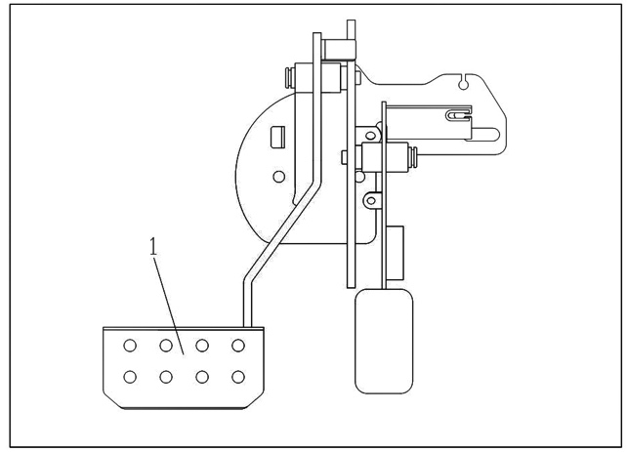

1. Brake pedal

Parking brake lever
Pull the parking lever up so that the unit can engage park brake. To release the brake, press the button on the front end of the parking lever, then push the parking lever down.
CAUTION
● Always pull up your parking brake when you leave your UTV.
● Adjust the parking cable if necessary.
● Be sure to fully release the parking
brake lever before starting the vehicle.

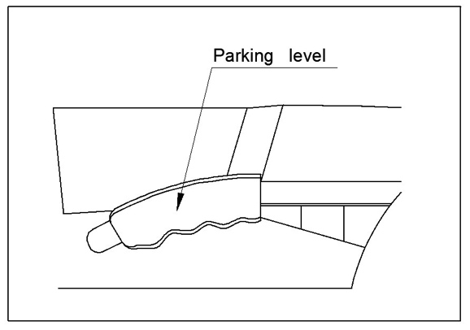

Parking Brake OFF
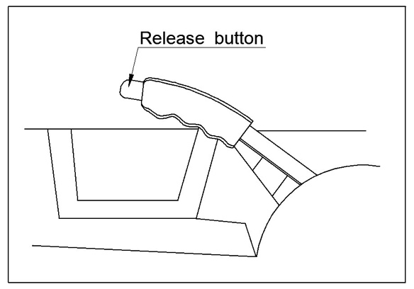

Parking Brake ON
Drive select lever
The gear stick is used to shift your vehicle the L—H—N—R—P and reverse positions.
CAUTION
● Only start UTV in park.
● Stop vehicle fully before shifting to reverse


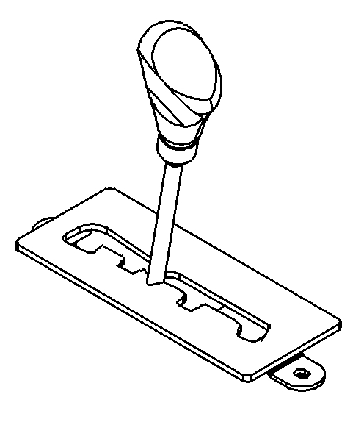

Fuel tank cap
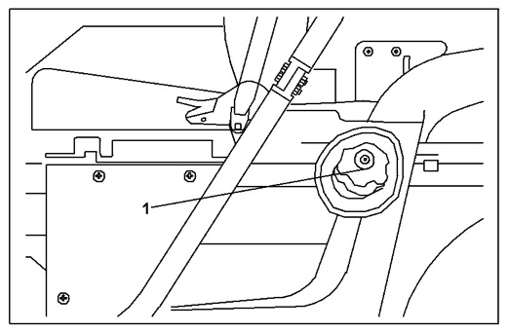
Remove tank cap by turning it counterclockwise.

1. Fuel tank cap

Seats
To remove a seat, pull its seat lock latch upward, lift the front of the seat, and then slide the seat forward and up.

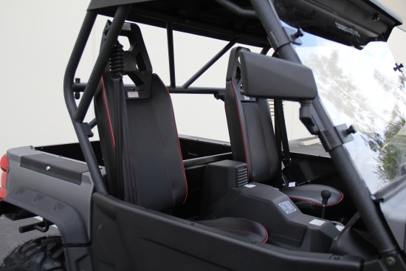

Driver seat Passenger seat

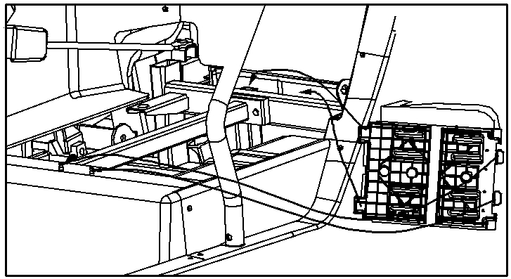

To install a seat, insert the fittings on the rear of the seat into the holders and push down on the seat at the front.

! WARNING
POTENTIAL HAZARD
A loose seat.
WHAT CAN HAPPEN
The operator could lose control or the operator or passenger could fall if the seat is loose during operation.
HOW TO AVOID THE HAZARD
Make sure the seat is securely latched.

Seat belts
This vehicle is equipped with three-point seat belts for both the operator and passenger. Always wear the seat belt while riding in the vehicle.

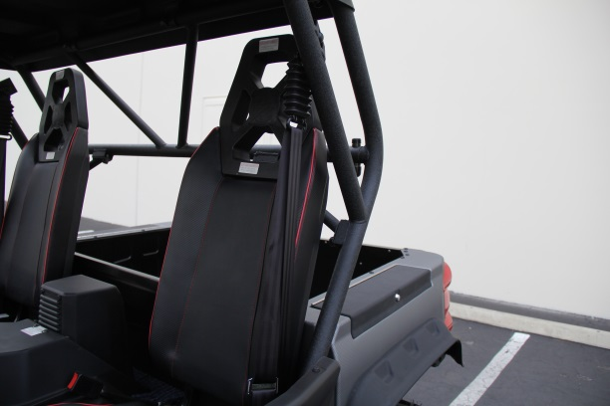

Seat belt (x2) Latch plate (x2)
Buckle (x2)

To wear the seat belt properly, do the following:
1. Hold the latch plate as you pull the belt across your lap and chest. Make sure the belt is not twisted and is not caught on any portion of the vehicle, your clothing, or any equipment you are carrying.
2. Push the latch plate into the buckle until it clicks. Pull up on the latch plate to make sure it is secure.
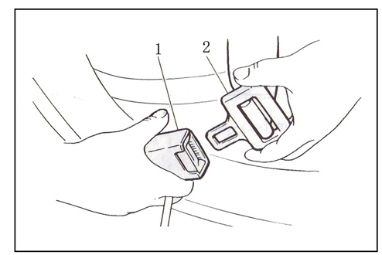

1. Buckle 2. Latch plate
3. Put the lap portion of the belt low on
your hips. Push down on the buckle
end of the belt as you pull up on the
shoulder part so the belt is snug
across your hips.
4. Position the shoulder belt over your shoulder and across your chest. The shoulder belt should fit against your chest. If it is loose, pull the belt out all the way and then let it retract.
5. To release the buckle, firmly press the release button.
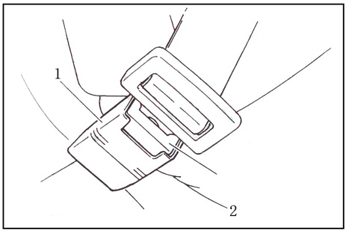

1. Buckle 2. Release button.
! WARNING
POTENTIAL HAZARD
Not wearing the seat belt.
Wearing the seat belt improperly.
WHAT CAN HAPPEN
There is increased risk of being killed or seriously injured in an accident.
HOW TO AVOID THE HAZARD
Always wear your seat belt when riding in the vehicle.
Be sure the seat belt is close-fitting across your hips and chest and is latched securely.

Glove compartment
CAUTION:
To protect from damage, do not put metal products, like tools or sharply edged products directly in the glove compartment. If they must be stored, wrap them in appropriate cushion material.
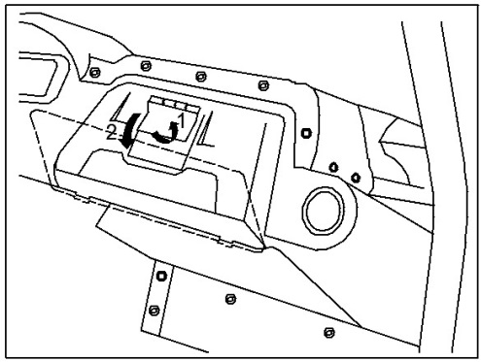

1. Unlock 2. Open

Cargo bed
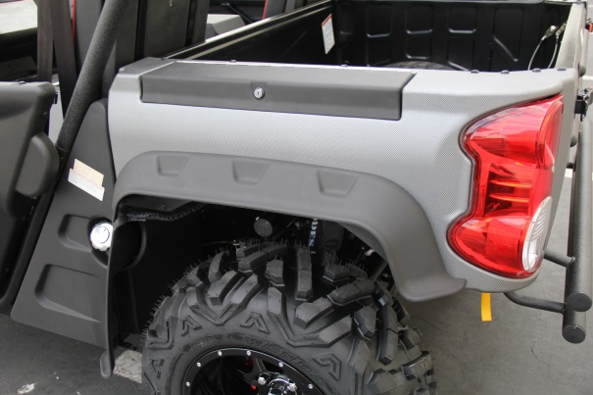

Cargo bed Tailgate
Cargo hook (x4)

Opening and closing the tailgate
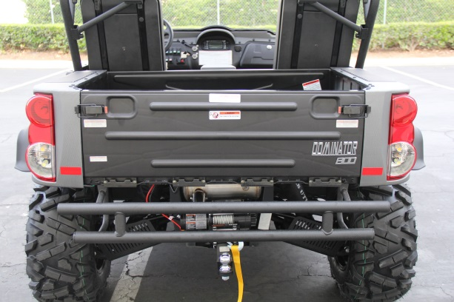

Tailgate Latch (x2)

To open
Unhook the latches then lower the tailgate.
To close
Place the tailgate in the original position then hook the latches.

Lifting and lowering the cargo bed
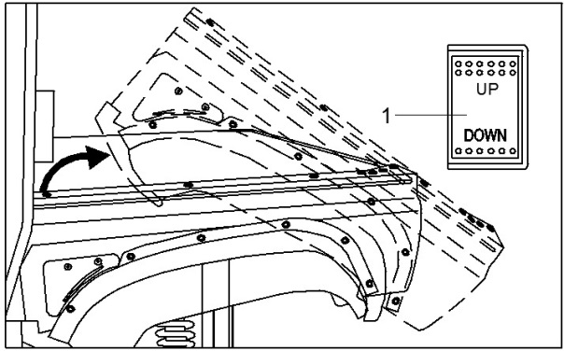

Raising：When trying to raising the cargo bed ,first turn key on ,then press “UP” button to end . seeing pic 1.
Landing: When trying to land the cargo bed, first turn key on ,then press “Down” button to end seeing pic 1.
To lift
Push down the cargo bed release lever on the left or right side of the vehicle, and then slowly lift up the cargo bed until it stops.
To lower
Lower the cargo bed slowly to its original position and be sure it is locked into place.
Maximum load limit: 50kg (110lbs)

! WARNING
POTENTIAL HAZARD
Pinch points.
WHAT CAN HAPPEN
You or someone else could be pinched between the cargo bed and the frame when the bed is being lowered.
HOW TO AVOID THE HAZARD
Before closing the bed, be sure others are standing away from the vehicle. Keep hands and fingers away from the pinch points between the bed and the frame.

! WARNING
POTENTIAL HAZARD
Overloading the cargo bed.
WHAT CAN HAPPEN
Could cause changes in vehicle handling which could lead to an accident.
HOW TO AVOID THE HAZARD
Never exceed the stated maximum load limit for this cargo bed.
Cargo should be properly distributed and securely attached.
Reduce speed when carrying cargo. Allow greater distance for braking.

! WARNING
POTENTIAL HAZARD
Carrying a passenger in the cargo bed.
WHAT CAN HAPPEN
The passenger could fall, be thrown out, or be struck by objects in the cargo bed.
HOW TO AVOID THE HAZARD
Never carry a passenger in the cargo bed. This cargo bed is designed to carry cargo only.
Trailer hitch bracket
This vehicle is equipped with a 5cm (2in) receiver bracket for a standard trailer hitch. Trailer towing equipment can be obtained at an authorized dealer.

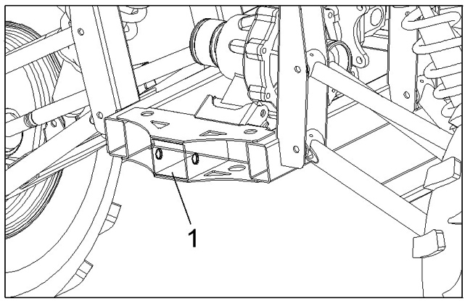

- Trailer hitch bracket

ARE YOU READY TO DRIVE
Before each drive, you need to make sure you and your UTV are both ready to drive. To help get you prepared, this section discusses how to evaluate your driving readiness, what items you should check on your UTV, and adjustments to make for your comfort, convenience, or safety.
Protective apparel
For your safety, we strongly recommend that you always wear an approved motorcycle helmet, eye protection, boots, gloves, long pants, and long-sleeved shirt or jacket whenever you drive. Wearing proper gear can reduce the chance of injury when you drive. The following suggestions will help you choose the proper driving gear.

Helmets and eye protection
Your helmet is your most important piece of driving gear because it offers the best protection against head injuries. A helmet should fit your head comfortably and securely.
An open-face helmet offers some protection, but a full-face helmet is recommended. Regardless of the style, look for a DOT (Department of Transportation) sticker in any helmet you buy. Always wear a face shield or goggles to protect your eyes and help your vision.

! WARNING
Operating this without wearing an approved motorcycle helmet, eye protection and protective clothing could increase your chances of head or eye injury, possibly death in the event of severe accident.
Always wear an approved motorcycle helmet that fits properly and wear goggles or a face shield to protect your eyes.

Additional riding gear
In addition to a helmet and eye protection, we also recommend:
● sturdy off-road motorcycle boots to
help protect your feet, ankles, and
lower legs.
● off-road motorcycle gloves to help
protect your hands.
● driving pants with knee and hip pads, a
driving jersey with padded elbows,
chest/shoulder protector.

Drive training
Developing your driving skills is an on-going process. Even if you have driven another UTV, take time to become familiar with this UTV in a safe area to build your skills. Do not drive in rough terrain until you get familiar with this UTV’s controls, and feel comfortable with its size and weight.
! WARNING
Operating UTV without proper instruction could increase your risk of an accident which could lead to serious injury or death.

! WARNING
Make sure to keep your arms and legs inside at all times and to always wear your seat belt. If your UTV begins to roll and turn over do not attempt to support the UTV by holding out your arms and trying to push off the ground which could lead to severe injury or death.
Age Recommendation
It is strongly recommended that no one under 16 years of age be permitted on this UTV without adult supervision.
! WARNING
A child driving a UTV that is not recommended for his/her age could lose control and result in severe injury or death.
A child under 16 years old must have adult supervision when operating this UTV.

No Alcohol or Drugs
Alcohol, drugs and driving don’t mix. Even a small amount of alcohol can impair your ability to operate a UTV safely. Likewise, drugs, even if prescribed by a physician, can be dangerous while operating a UTV. Consult your doctor to be sure it is safe to operate a vehicle after taking medication.
! WARNING
Operating this UTV after consuming alcohol or drugs can seriously affect your judgment, slow your reaction time, affect balance and perception, and could result in serious injury or death.
Never consume alcohol or drugs before or while operating this UTV.

IS YOUR VEHICLE READY TO DRIVE
It is important to inspect your UTV before each drive. A pre-drive is a must to ensure there are no problems and to help prevent any collisions or harm to you are any bystanders.
If your UTV has overturned or has been involved in a collision, do not drive it until you have had your UTV inspected by your dealer. There maybe damages or other problems you can not see.

! WARNING
Improper maintenance of this UTV or failure to correct a problem before driving can cause a crash resulting in serious injury or death.
Always perform an inspection before every drive and correct any problems.

Pre-drive Inspection
The following items need to be checked before you get on the UTV:
● Engine oil
Look for any leaks. Check the level
of oil and add if needed.
● Coolant
Check for leaks. Add coolant if needed.
● Fuel
Check the level and add fuel if needed. Make sure the fuel cap is securely fastened. Check for leaks.
● Tires
Use a gauge to check the tire pressure. Adjust if needed. Also look for signs of damages or excessive wear.
● Nut & Bolts
Check the wheels to see that the axle nuts are tightened.
● Underbody & Exhaust System
Check for, and remove any dirt, brush or other debris that could be a fire hazard or interfere with the proper operation of the UTV.
● Air Cleaner
Check the air filter. Replace if needed.
● Leaks, Loose Parts
Inspect your UTV and look for
anything that appears unusual,
such as a leak or loose cable.
● Lights
Make sure the headlights, brake lights, and tail lights are working properly.
● Throttle
Check the free play and adjust if needed. Press the throttle to make sure it moves smoothly without sticking and snaps back automatically when it is released.
● Clutch pedal
Check the free play of the clutch pedal and adjust if needed. Press the clutch cable to make sure it moves smoothly without sticking and snaps back automatically when it is released.
● Brakes
Press the brake pedal several times, check for proper brake pedal free play. Make sure there is no brake fluid leakage.
● Engine stop
When engine is running, turn the switch key counterclockwise. Make sure engine stops.
● Steering Wheel
Check that the wheel turns correctly.
●Cable
Check the cable housing for wear. Check that all fittings are tight. Replace or tighten as needed.
●Tie rod
Check the tie rod housing for wear.
Check that all fittings are tight. Replace or tighten as needed.

Safe driving precautions
Off-road use only
Your UTV and its tires are designed and manufactured for off-road use only. Do not drive on pavement. Driving on pavement can affect handling and control.

! WARNING
Operating this UTV on paved surfaces may seriously affect handling and control of the UTV, and may cause the vehicle to go out of control.
Never operate on any paved surfaces, including sidewalks, driveways, parking lots and streets.

When driving off-road, remember to obey local off-road driving laws and regulations. Obtain permission to drive on private property. Avoid posted areas and obey “no trespassing” signs.
You should never drive your UTV on public streets, roads, or highways, even if they are not paved. In many states it is illegal to operate a UTV on public streets, roads and highways drivers of street vehicles may have difficulty seeing and avoiding you, which could lead to a collision.

! WARNING
Operating this UTV on paved surfaces may seriously affect handling and control of the UTV, and may cause the vehicle to go out of control.
Never operate the UTV on any paved surfaces, including sidewalks.
Keep hands and feet on controls
Always keep both hands on the steering wheel and your feet on the controls. When driving your UTV, it is important to maintain your balance and control of the UTV. Removing hands or feet away from the controls can reduce your ability to react and control the vehicle.

! WARNING
Removing your hands from the steering wheel or feet from foot controls during operation can reduce your ability to control the UTV.
Always keep both hands on the steering wheel and both feet on the foot controls of your UTV during operation.
Control speed
Driving at excessive speed increases the chance of an accident. In choosing a proper speed, you need to consider the capability of your UTV, the terrain, visibility, other operating conditions, and your own skills and experience.
! WARNING
Operating this UTV at excessive speeds increases your changes of losing control of the UTV, which can result in an accident.
Always drive at a speed that is proper for your UTV, the terrain, visibility, other operating conditions, and your experience.
Take Pre-Caution on Unfamiliar or Rough Terrain
Before driving in a new area, always check the terrain thoroughly. Do not drive fast on unfamiliar terrain or when visibility is limited. (It’s sometimes difficult to see and react to hidden rocks, bumps, or holes.)
! WARNING
Failure to take pre-caution when operating this UTV on unfamiliar terrain could result in the UTV overturning or losing control.
Go slowly and be extra cautious when operating on unfamiliar terrain. Always be alert to changing terrain conditions when operating the UTV.
Never drive past the limit of visibility.
Maintain a safe distance between you and other off-road vehicles. Always exercise caution on rough, slippery and loose terrain.

! WARNING
Failure to take extra pre-caution when operating on excessively rough, slippery or loose terrain could cause loss of traction or vehicle control, which could result in an accident, or overturned vehicle.
Do not operate on excessively rough, slippery or loose terrain until you have learned and practiced the skills necessary to control the UTV on such terrain. Be extra careful on these types of terrain.
Do Not Perform Stunts
You should always operate your UTV in a safe and reasonable manner. When driving keep all wheels on the ground.
! WARNING
Attempting wheelies and other stunts increases the chance of an accident, including an overturn.
Never attempt stunts, such as wheelies or jumps.
Parking Adjustment
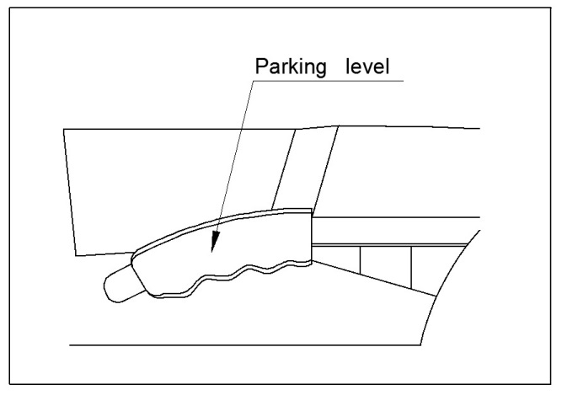

Parking Break OFF
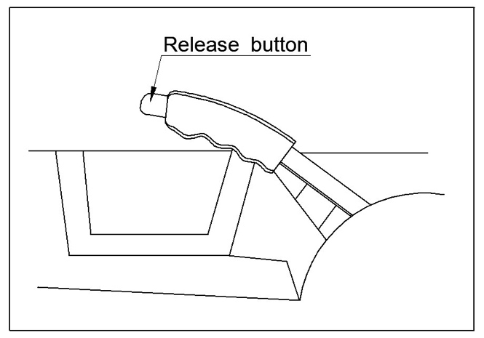

Parking Break ON
● Pull the park brake lever up to engage the parking brake.
● To release the unit, press button on front end of parking lever then push the parking lever to the bottom.
● Adjust the parking cable if necessary.

Gear Shift Adjustment
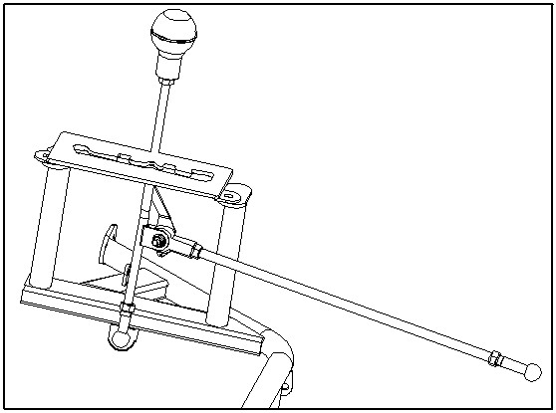

Before operating the vehicle, check the shift lever as to change gearshift from 1 to 5 and reverse smoothly.
The shift lever should be vertical when the gear is in neutral. If not, adjust the shift cable and then tighten the nuts of the shift cable.
Break-in
The first month is most important in the life of your vehicle. Proper operation during this break-in period will help ensure maximum life and performance from your new vehicle. The following guidelines explain proper break-in procedures.
1、After the engine starts, the engine should not go above 5000rpm for the first 20 hours.
2、Drive vehicle slowly, do not accelerate
quickly for the first 20 hours.
3、Avoid slamming the brakes.
4、Do not exceed the vehicle speed on the below schedule.

Starting and Operating Instructions
● Before starting the engine, be sure
that the driver is seated properly in the UTV and tighten the seat belts.
● Test the UTV in an open area at the
beginning to learn how to start, turn and stop.
● Operate the UTV slowly until you become familiar with it. The turning radius on this vehicle is very small, so the centrifugal force is very high when turning at a high speed. Slow down around corners or turns to reduce the risk of overturning your UTV.

Auxiliary DC jack
The auxiliary DC jack is located at the right side of the front panel. This jack can be used for suitable portable players. Only use the DC jack while engine is running.
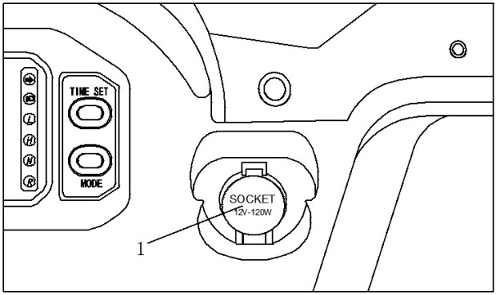

1. Auxiliary DC jack cable
1. Set the light switch to “OFF”.
2. Start the engine.
3. Open the auxiliary DC jack cap, and
then insert the accessory power plug
into the jack.
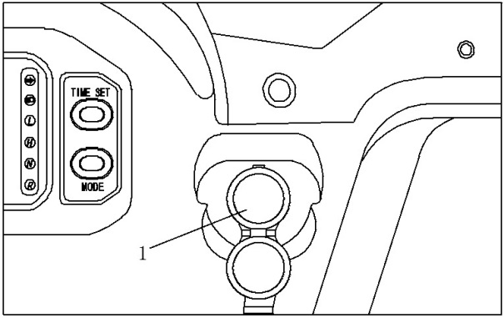

1. Auxiliary DC jack
Maximum rated capacity for the auxiliary DC jack:
DC 12V,120W(10A)

4. When the auxiliary DC jack is not being used, cover it with the cap.

CAUTION:
●Do not use accessories use accessories more than the above maximum capacity. This may overload the circuit and cause the fuse to blow.
●If accessories are used without the engine running or with the headlights turned on, the battery will lose its charge and engine starting may become difficult.
●Do not use an automotive cigarette lighter or other accessories with a plug that gets hot.

PRE-OPERATION CHECKS
Before using this vehicle, check the following points
! WARNING
POTENTIAL HAZARD
Failure to inspect the vehicle before operating and failure to properly maintain the vehicle.
WHAT CAN HAPPEN
Increases the possibility of an accident or equipment damage.
HOW TO AVOID THE HAZARD
Inspect your vehicle before each use to make sure the vehicle is in safe operating condition. Always follow the inspection and maintenance procedures and schedules described in the Owner’s Manual.
Front and rear brakes
Brake fluid leakage
Check to see if any brake fluid is leaking out of the pipe joints or the brake fluid reservoir. Apply the brakes firmly for one minute. If there is any leakage, have the vehicle inspected by an authorized dealer.
Brake operation
Test the brakes at slow speed after starting out to make sure they are working properly. If the brakes do not provide proper braking performance, inspect the brake system. If needed, have the vehicle inspected by an authorized dealer.

! WARNING
POTENTIAL HAZARD
Driving with inoperable brakes.
WHAT CAN HAPPEN
You could lose braking ability, which could lead to an accident.
HOW TO AVOID THE HAZARD
Check your brakes before each ride. Do not operate the vehicle if you find any problem with the brakes.
If a problem cannot be corrected by the adjustment procedures provided in this manual, have the vehicle inspected by an authorized dealer.

Fuel
Make sure there is sufficient gasoline in the tank.

CAUTION:
Use only unleaded gasoline. The use of leaded gasoline will cause severe damage to internal engine parts, such as the valves, piston rings, and as well as damage to the exhaust system.

Gasoline Type
There are two types of gasoline; gasoline containing ethanol and that containing methanol. Gasoline containing ethanol can be used if ethanol content does not exceed 10%. Gasoline containing methanol is not recommended because it may cause fuel system damage or vehicle performance problems.

! WARNING
POTENTIAL HAZARD
Improper care when refueling.
WHAT CAN HAPPEN
Fuel can spill, which can cause a fire and severe injury.
Fuel expands when it heats up.
If the fuel tank is overfilled, fuel could spill out due to heat from the engine or the sun.
HOW TO AVOID THE HAZARD
Do not overfill the fuel tank. Be careful not to spill fuel, especially on the engine or exhaust pipe. Wipe up any spilled fuel immediately. Be sure the fuel tank cap is closed securely.

Accelerator pedal
Check to see that the gas pedal operates correctly. It must operate smoothly and fully spring back to the idle position when released. Have a dealer repair if necessary for proper operation.
Seat belts
Make sure that both seat belts are not frayed or damaged.
The seat belt must move smoothly when pulled. The latch plate should click securely into the buckle and release when the release button is pushed. Wash off any dirt or mud which could affect operation. Have a dealer repair if necessary for proper operation.
Steering
Park on level ground. Turn the steering wheel right and left. Check for excessive free play, abnormal noises, or a rough feeling. Have a dealer repair if necessary for proper operation.
Fittings and fasteners
Always check the tightness of chassis fittings and fasteners before a ride. Take the vehicle to an authorized dealer or refer to the Service Manual for correct torque specifications.
Lights
Check the headlights and tail/brake lights to make sure they are in working condition. Repair if necessary for proper operation.
Switches
Check the operation of all switches. Have a dealer repair if necessary for proper operation.

Tires
! WARNING
POTENTIAL HAZARD
Operating this vehicle with improper tires or with uneven tire pressure.
WHAT CAN HAPPEN
Use of improper tires on this vehicle, or operation of this vehicle with improper or uneven tire pressure, may cause loss of control increasing your risk of accident.
HOW TO AVOID THE HAZARD
1. The tires listed below have been approved by motor Manufacturing Corporation of America for this model. Other tire combinations are not recommended.
2. The tires should be set to the recommended pressure:
● Recommended tire pressure
Front & Rear
25 kPa (0.25 kgf/cm², 3.6psi)
Check and adjust tire pressures when the tires are cold.
Tire pressures must be equal on both sides.
3. Tire pressure below the minimum specified could cause the tire to dislodge from the rim under severe riding conditions. The following are minimums:
Front & Rear
22 kPa (0.22 kgf/cm², 3.2 psi)
Higher pressures may cause the tire to burst. Inflate the tires very slowly and carefully. Fast inflation could cause the tire to burst.
How to measure tire pressure
Use the tire pressure gauge.

NOTE:
The tire pressure gauge is not included as standard equipment. Make two measurements of the tire pressure and use the second reading. Dust or dirt in the gauge could cause the first reading to be incorrect.
 | Recommended  pressure | Minimum | Maximum
Front  &  Rear | 70 kPa  (0.71 kgf/cm²,  10.2 psi) | 63 kPa  (0.64  kgf/cm²,  9 psi) | 77 kPa  (0.77  kgf/cm²,  11 psi)

Set pressure with tires cold.
Set tire pressures to the following specifications:
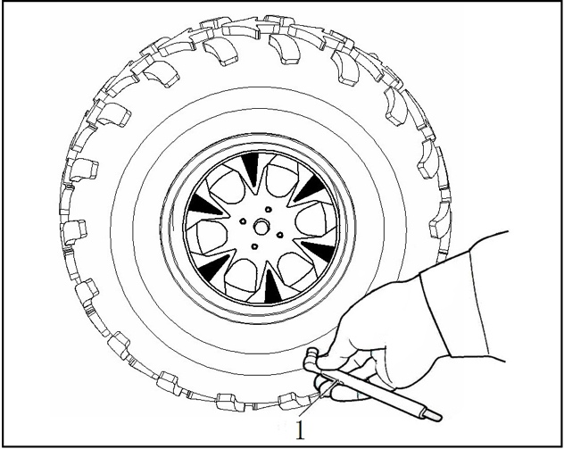

1. Tire pressure gauge

Tire wear limit
When the tire groove decreases to 6 mm (0.24 in) due to wear, replace the tire.

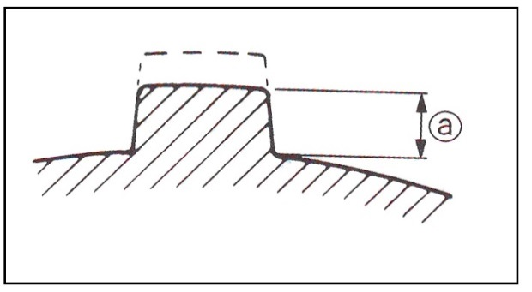

- Tire wear limit

OPERATION
! WARNING
POTENTIAL HAZARD
Operating vehicle without being familiar with all controls.
WHAT CAN HAPPEN
Loss of control, which could cause an accident or injury.
HOW TO AVOID THE HAZARD
Read the Owner’s Manual carefully. If there is a control or function you do not understand, ask your dealer.

Jump-starting
Jump-starting the vehicle should be avoided. The battery should be removed and charged instead. However, if the vehicle must be jump-started, proceed as follows:
1. Turn the key to “OFF”.
2. Open the hood. Remove the battery compartment cover.
3. Using a charged 12V battery, connect
the positive lead of the jumper cable
to the positive terminal on the battery
in the vehicle and the other end of the
positive lead to the positive terminal
of the charged battery.
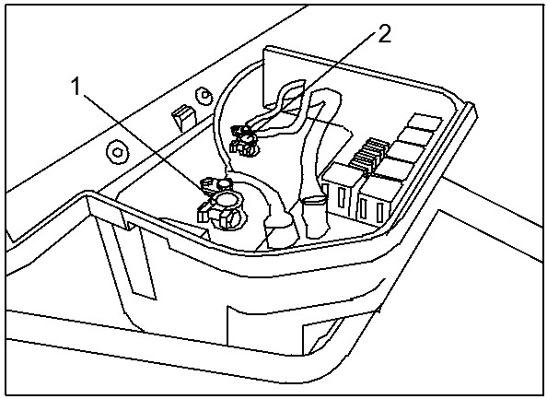

1. Jumper cable positive lead
2. Jumper cable negative lead
4. Connect the negative lead of the jumper cable to the negative terminal of the negative lead to an unpainted metal surface of the vehicle.

! WARNING
Do not connect the negative lead of the jumper cable to the negative terminal of the battery in the vehicle.
● Be especially careful not to touch the positive lead of the jumper cable to the negative lead or not to reverse the polarity of the jumper cables when connecting to the batteries-battery, explosion and/or serious damage to the electrical system may occur.

5. Start the engine.
6. After the engine starts, disconnect the negative lead of the jumper cable from the vehicle and charged battery, then disconnect the positive lead of the jumper cable from the charged battery and the battery in the vehicle.
7. Install the battery compartment cover.
8. Put the seat back in place.

Warming up
To get maximum engine life, always warm up the engine before starting off. Never accelerate fast with a cold engine!
Shifting: Neutral to Reverse
1. Stop the vehicle. Keep your foot off the gas pedal.
2. Apply the brake pedal.
3. Shift from neutral to reverse or vice versa by moving the drive select lever along the shift guide.
4. Check behind for any people or obstacles, and then release the brake pedal.
5. Press the gas pedal gradually and continue to watch to the rear while backing.

NOTE:
- When in reverse, the reverse indicator light should be on. If the light does not come on, ask a dealer to inspect the reverse indicator light electrical circuit.
- Due to the synchronizing mechanism in the engine, the light may not come on until the vehicle starts moving.
! WARNING
POTENTIAL HAZARD
Carelessly operating in reverse.
WHAT CAN HAPPEN
You could hit an obstacle or person behind you, resulting in serious injury or death.
HOW TO AVOID THE HAZARD
When you shift into reverse,
make sure there are no obstacles or people behind you. When it is safe to proceed, accelerate slowly.

Engine break-in
There is never a more important period in the life of your vehicle than the period between zero and 20 hours.
For this reason, we ask that you carefully read the following material. Because the engine is brand new, you must not push it excessively for the first several hours of running. During the first 20 hours, various parts of the engine wear and lubricate themselves to the correct operating clearances.
During this period, prolonged full throttle operation or any condition might result in excessive engine heating, this must be avoided. However, momentary (2-3 seconds maximum) full throttle operation under load does not harm the engine.
Each full throttle acceleration sequence should be followed with a substantial rest period for the engine by riding at lower r/min so the engine can recover from the temporary build up of heat. If any abnormality is noticed during this period, consult an authorized dealer.
0-10 hours:
Avoid continuous operation above half throttle. Allow a cooling period of five to ten minutes after every hour of operation. Vary the speed of the vehicle from time to time. Do not operate it at one set throttle position.
10-20 hours:
Avoid prolonged operation above 3/4 throttle. Rev the vehicle freely but do not use full throttle at any time.
After break-in:
The vehicle can now be operated normally.
Parking
When parking, stop the engine and shift the drive select lever into the neutral position. Apply the parking brake to help prevent the vehicle from rolling.
Parking on a slope
! WARNING
POTENTIAL HAZARD
Parking on a hill or other incline.
WHAT CAN HAPPEN
The vehicle could roll out of control, increasing the chance of an accident.
HOW TO AVOID THE HAZARD
Avoid parking on hills or other inclines. If you must park on an incline, apply the parking brake, and block the front and rear wheels with rocks or other objects. Do not park the vehicle on a steep incline.

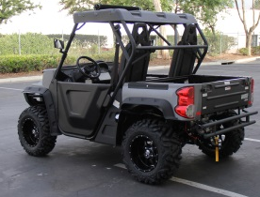

1. Bring the vehicle to a stop by applying the brakes.
2. Stop the engine.
3. With the brakes applied, set the
parking brake.

NOTE:
Like many other vehicles, the parking brake acts on the rear wheels. For the parking brake to have the effect of braking all four wheels, shift to 4WD before stopping the engine.

Accessories and loading
Accessories
Accessories can affect the handling and control of your vehicle. Keep the following in mind when considering an accessory or operating a vehicle which has accessories.
●Choose only accessories designed for your vehicle. Your dealer has a variety of genuine accessories. Other accessories may also be available on the market. However, it is not possible for us to test all accessories for quality or fitting. Choose a genuine accessory, or one that is equivalent in design and quality.
● Accessories should be securely mounted. An accessory that shifts position or comes off while you are operating could affect your ability to control the vehicle.
● Do not mount an accessory where it could interfere with your ability to control the vehicle. Examples include (but are not limited to) an object that limits your ability to turn the steering wheel or one that limits your view.
● Use extra caution when driving a vehicle with accessories. The vehicle may handle differently than it does without accessories.
Loading
Cargo or a trailer can change the stability and handling of a vehicle.
You must practice good judgment when carrying cargo or towing a trailer.
Keep the following points in mind:
● Do not exceed the weight limits shown. An overloaded vehicle can be unstable.
● Choose a trailer with a hitch designed for use with a 5 cm (2in) receiver.
● Do not exceed the maximum tongue weight. You can measure tongue weight with a bathroom scale. Put the tongue of the loaded trailer on the scale with the tongue at hitch height. Adjust the load in the trailer, if you are carrying cargo and towing a trailer, include the tongue weight in the maximum vehicle load limit.
● Load cargo in the cargo bed as close to the center of the vehicle as possible and tie it down using the cargo hooks equipped on the cargo bed.
● Tie down cargo securely in the trailer. Make sure cargo in the trailer cannot move around.
A shifting load can cause an accident.
● Make sure the load does not interfere with controls or your ability to see where you are going.
● Drive more slowly than you would without a load. The more weight you carry, the slower you should go. Although conditions vary, it is good practice not to exceed low range whenever you are carrying heavier loads or when towing a trailer.
● Allow more braking distance.
A heavier vehicle takes longer to stop.
● Avoid making sharp turns at high speeds.
● Avoid hills and rough terrain. Added weight affects the stability and handling of the vehicle.
! WARNING
POTENTIAL HAZARD
Overloading this vehicle or carrying or towing cargo improperly.
WHAT CAN HAPPEN
Could cause changes in vehicle handling which could lead to an accident.
HOW TO AVOID THE HAZARD
Never exceed the stated load capacity for this vehicle.
Cargo should be properly distributed and securely attached.
Reduce speed when carrying cargo or pulling a trailer. Allow greater distance for braking.

DRIVING YOUR VEHICLE
GETTING TO KNOW YOUR VEHICLE
This off-highway utility vehicle will handle and maneuver differently from an ordinary passenger car or other vehicle.
Before you begin to use your vehicle, be sure you have read this Owner’s Manual completely and understand the operation of the controls, as well as the warning and caution labels on the unit.
This vehicle is designed for one operator and one passenger. The driver and passenger must always wear a seat belt. Never carry passengers in the cargo bed.
! WARNING
POTENTIAL HAZARD
Not wearing a seat belt.
Improperly wearing seat belts.
WHAT CAN HAPPEN
There is a higher chance of severe injury or death.
HOW TO AVOID THE HAZARD
Always wear your seat belt when riding in the vehicle.
Be sure the seat belt is close-fitting across your hips and chest and is latched securely.

! WARNING
POTENTIAL HAZARD
Carrying a passenger in the cargo bed.
WHAT CAN HAPPEN
The passenger could fall or be struck by objects in the cargo bed.
HOW TO AVOID THE HAZARD
Never carry a passenger in the cargo bed. The cargo bed is designed to carry cargo only.
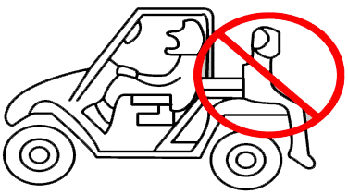

! WARNING
POTENTIAL HAZARD
Overloading the vehicle and towing improperly.
WHAT CAN HAPPEN
Could cause changes in vehicle handling which could lead to an accident and/or injury.
HOW TO AVOID THE HAZARD
Never exceed the stated load capacity for this vehicle.
Cargo should be properly distributed and securely attached.
Reduce speed when carrying cargo or pulling a trailer and allow greater distance for braking. Follow all instructions in your Owner’s Manual for carrying cargo or pulling a trailer.

The driver and passenger must always wear a seat belt and an approved motorcycle helmet, eye protection, protective clothing (boots, long pants, long-sleeved shirt, goggles). Keep your hands and feet inside the vehicle at all times.

! WARNING
POTENTIAL HAZARD
Operating this vehicle without wearing an approved motorcycle helmet, eye protection, and protective clothing.
WHAT CAN HAPPEN
Not wearing a helmet increases your chances of a severe head injury or death in the event of an accident. Operating without eye protection can result in an accident and increases your chances of a severe injury in the event of an accident.
HOW TO AVOID THE HAZARD
Always wear an approved motorcycle helmet that fits properly.
You should also wear:
1. Eye protection
2. A long-sleeved shirt or jacket
3. Gloves
4. Boots
5. Long pants
TURNING YOUR VEHICLE
Whether you are on normal or rough terrain, it is possible for the vehicle to roll over or go out of control if you attempt sharp, high-speed turns. Do not attempt to turn around or make abrupt maneuvers on slopes.
Position your hands on the steering wheel so that your thumbs and fingers do not wrap around the wheel. This is particularly important when driving in rough terrain. The front wheels will move right and left as they respond to the terrain, and this movement will be felt in the steering wheel. A sudden jolt could yank the steering wheel around, and your thumbs or fingers could be injured if they are in the way of the steering wheel spokes.

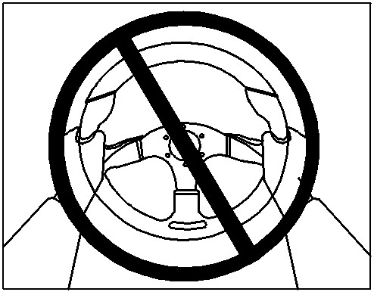

Braking
Braking ability is affected by the type of terrain. In most cases, gradual application of the brakes is more effective than abrupt braking, particularly on loose surfaces like gravel. Always allow for greater braking distance on rough, loose, or slippery surfaces.
Going uphill
Do not attempt to climb hills until you have mastered basic maneuvers on flat ground. Use proper driving techniques to avoid overturns on hills and slopes. Drive straight up hills, and avoid crossing the side of a hill, which increases your chance of rollover. Practice first on gentle slopes before attempting steeper hills. Always check the terrain carefully before attempting any hill. Use common sense and remember that some hills are too steep for you to climb.
Maximum slope angle: 15°
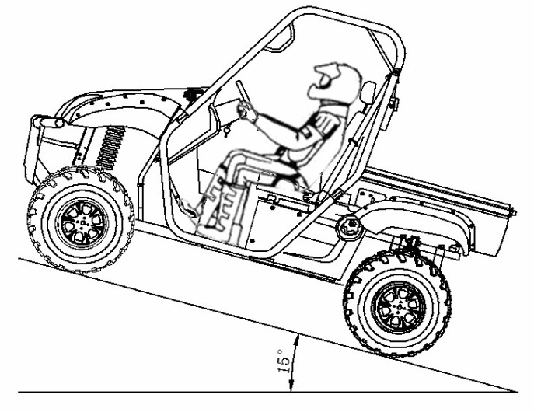

Choose carefully which hills you attempt to climb. Avoid hills with slippery surfaces or ones where you will not be able to see far enough ahead of you.
! WARNING
POTENTIAL HAZARD
Operating on excessively steep hills.
WHAT CAN HAPPEN
The vehicle can overturn more easily on extremely steep hills than on level surfaces or small hills.
HOW TO AVOID THE HAZARD
Never operate your vehicle on hills too steep for it or your abilities. Never operate vehicles on hills steeper than 15°.
Do not drive across the face of a hill. Go straight up the hill.
Practice on smaller hills before attempting large hills.

If you start to lose traction or momentum when climbing, use the brakes to come to a stop. Do not attempt to turn the vehicle around. With your foot on the brake, look behind you and plan your descent. Shift the drive select lever in reverse so you can use the engine brake if necessary to slow your descent. Release the brake and begin to coast down the hill. Use engine braking as much as possible, gently applying the brakes when necessary.

Going downhill
Check the terrain carefully before going down a hill. When possible, choose a path that lets you drive your vehicle straight downhill. Avoid sharp angles that could allow the vehicle to roll over. Carefully choose your path and drive no faster than you will be able to react to obstacles that may appear.

! WARNING
POTENTIAL HAZARD
Going down a hill improperly.
WHAT CAN HAPPEN
Could cause loss of control or cause the vehicle to overturn.
HOW TO AVOID THE HAZARD
Always check the terrain carefully before you start down any hill. Never go down a hill at high speed. Avoid going down a hill at an angle that would cause the vehicle to lean sharply to one side. Go straight down the hill where possible.

On most slopes, you may use engine braking to help you go downhill slowly. Go as slowly as possible. If you start to go too fast, gently apply brakes. Sudden application of the brakes could cause the vehicle to start sliding.
If you begin to slide or skid, try to steer in the direction the vehicle is sliding to help you regain control.
If you must turn on the hill to avoid an obstacle, do so slowly and carefully. If the vehicle starts to tip, gradually steer in the downhill direction if there are no obstacles in your path. As you regain proper balance, gradually steer again in the direction you want to go.

Crossing through shallow water
If you must cross shallow water, choose your path carefully to avoid sharp drop-offs, large rocks, or slippery surfaces that could cause the vehicle to overturn. Never operate through water deeper than 33 cm (13 in) or fast flowing water.
Wet brakes may have reduced effectiveness. After leaving the water, test your brakes. If necessary, apply the brakes several times to let friction dry out the linings.

! WARNING
POTENTIAL HAZARD
Operating this vehicle through deep or fast-flowing water.
WHAT CAN HAPPEN
Loss of control, which could result in an accident or overturn, increasing the risk of drowning.
HOW TO AVOID THE HAZARD
Never operate this vehicle in fast flowing water or in water deeper than 33 cm (13 in).
Remember that wet brakes may have reduced stopping ability. Test your brakes after leaving water. If necessary, apply the brakes several times to let friction dry out the linings.

CAUTION:
After riding your vehicle in water, be sure to drain the trapped water by removing the check hose at the bottom of the air filter case. Wash the vehicle in fresh water if it has been operated in salt water or muddy conditions.

Riding over rough terrain
Operating over rough terrain should be done with caution. Look for obstacles that could cause damage to the vehicle or could lead to a rollover or accident. Avoid jumping the vehicle as injury, loss of control, and damage to the vehicle could occur.
! WARNING
POTENTIAL HAZARD
Failure to be cautious when operating this vehicle on unfamiliar terrain.
WHAT CAN HAPPEN
You can come upon hidden rocks, bumps, or holes, without enough time to react. This could cause the vehicle to go out of control.
HOW TO AVOID THE HAZARD
Go slowly and be extra careful when operating on unfamiliar terrain. Always be alert to changing terrain conditions when operating the vehicle.

Riding in brush or wooded areas
When operating in areas with brush or trees, take care to avoid hitting any branches or obstructions as you pass. Never hold onto the roll cage so your hand is outside the vehicle. Hold onto the handgrip INSIDE the roll cage.

Encountering obstacles on the trail
If you cannot go around an obstacle such as a fallen tree trunk or a ditch, stop the vehicle where it is safe to do so. Set the parking brake and get out to inspect the area thoroughly. Look from both your approach and the exit. If you believe you can continue safely, decide the path that will allow you to a right angle as possible to minimize vehicle tipping. Go only fast enough to maintain your momentum but still give yourself plenty of time to react to changes in conditions. If there is any question about your ability to maneuver safely over the obstacle, you should turn around, or back up until you find a less difficult path.

! WARNING
POTENTIAL HAZARD
Improperly operating over obstacles
WHAT CAN HAPPEN
Could cause loss of control or a collision. Could cause the vehicle to overturn.
HOW TO AVOID THE HAZARD
Before operating in a new area, check for obstacles.
Use extreme caution when operating over large obstacles, such as large rocks or fallen trees.

PERIODIC MAINTENANCE Periodic inspection, adjustment and lubrication will keep your vehicle in the safest and most efficient condition possible. Safety is an obligation of the operator for vehicle inspection. Adjustment and lubrication is explained in the following pages.

Periodic maintenance/lubrication
NOTE:
● For vehicles not equipped with an odometer or hour meter, follow the month maintenance intervals.
● For vehicles equipped with an odometer or an hour meter, follow the km(mi) or hours maintenance intervals. However, keep in mind that if the vehicle isn’t used for a long period of time, the month maintenance intervals should be followed.
● Items marked with an asterisk should be performed by a dealer as they require special tools, data and technical skills.
ITEM | ROUTINE | Whichever  Comes first  → |  | INTIAL |  |  | EVERY
ITEM | ROUTINE | Whichever  Comes first  → | month | 1 | 3 | 6 | 6 | 12
ITEM | ROUTINE | Whichever  Comes first  → | (mi) | (100) | (500) | (1000) | (2000) | (3000)
ITEM | ROUTINE | Whichever  Comes first  → | hours | 5 | 25 | 50 | 100 | 200
Valves* | ●Check vale clearance.  ●Adjust if necessary. |  |  | ○ |  | ○ | ○ | ○
Cooling system | ●Check coolant leakage.  ●Repair if necessary.  ●Replace coolant every 24 months. |  |  | ○ | ○ | ○ | ○ | ○
Spark plug | ●Check condition.  ●Adjust gap and clean. |  |  | ○ | ○ | ○ | ○ | ○
Air filter elements  (engine and air intake duct) | ●Clean.  ●Replace if necessary. |  |  | Every 20-40 hours  (More often in wet or dusty areas.)
Throttle Bottle* | ●Check idle speed/starter operation.  ●Adjust if necessary. |  |  |  | ○ | ○ | ○ | ○
Crankcase breather system* | ●Check breather hose for cracks or damage.  ●Replace if necessary. |  |  |  |  | ○ | ○ | ○
Exhaust system* | ●Check for leakage.  ●Tighten if necessary.  ●Replace gasket(s) if necessary. |  |  |  |  | ○ | ○ | ○
Spark arrester | ●Clean. |  |  |  |  | ○ | ○ | ○
Fuel line* | ●Check fuel hose for cracks or damage..  ●Replace if necessary. |  |  |  |  | ○ | ○ | ○
Engine oil | ●Replace (warm engine before draining) . |  |  | ○ |  | ○ | ○ | ○
Engine oil filter cartridge | ●Replace. |  |  | ○ |  | ○ |  | ○
Final gear oil | ●Check oil level/oil leakage.  ●Replace. |  |  | ○ |  |  |  | ○
Differential gear oil
ITEM | ROUTINE | Whichever  Comes first  → |  | INTIAL |  |  | EVERY
ITEM | ROUTINE | Whichever  Comes first  → | month | 1 | 3 | 6 | 6 | 12
ITEM | ROUTINE | Whichever  Comes first  → | (mi) | (100) | (500) | (1000) | (2000) | (3000)
ITEM | ROUTINE | Whichever  Comes first  → | hours | 5 | 25 | 50 | 100 | 200
Front brake* | ●Check operation/brake pad wear/fluid leakage.  ●Correct if necessary. Replace pads if worn to the limit. |  |  | ○ | ○ | ○ | ○ | ○
Rear brake* | ●Check operation/brake pad wear/fluid leakage.  ●Correct if necessary. Replace pads if worn to the limit. |  |  | ○ | ○ | ○ | ○ | ○
Accelerator pedal* | ●Check operation and free play. |  |  | ○ | ○ | ○ | ○ | ○
Wheels* | ●Check balance/damage/alignment/pressure.  ●Repair if necessary. |  |  | ○ |  | ○ | ○ | ○
Wheel bearings* | ●Check bearing assemblies for looseness/damage..  ●Replace if damaged. |  |  | ○ |  | ○ | ○ | ○
Front and rear  Suspension* | ●Check operation and for leakage.  ●Correct if necessary. |  |  | ○ |  | ○ |  | ○
Steering system* | ●Check operation and for looseness/Replace if damage.  ●Check toe-in/Adjust if necessary. |  |  | ○ | ○ | ○ | ○ | ○
Rear upper and lower knuckle pivots* | ●Lubricate with lithium-soap-based grease. |  |  |  |  | ○ | ○ | ○
Drive shaft universal joint* | ●Lubricate with lithium-soap-based grease. |  |  |  |  | ○ | ○ | ○
Engine mount* | ●Check for cracks or damage.  ●Correct bolt tightness. |  |  | ○ |  | ○ | ○ | ○
Front and rear axle boots* | ●Check operation.  ●Replace if damage. |  |  | ○ |  |  |  | ○
Stabilizer bushings* | ●Check for cracks or damage. |  |  | ○ |  | ○ | ○ | ○
Fittings and fasteners* | ●Check all chassis fittings and fasteners.  ●Correct if necessary. |  |  | ○ | ○ | ○ | ○ | ○
NOTE:
● Recommended brake fluid: DOT4
● Brake fluid replacement:
● Replace the brake hoses every four years, or if cracked or damaged.
● When disassembling the master cylinder or caliper, replace the brake fluid.
Normally check the brake fluid level and add fluid as required.
● On the inner parts of the master cylinder and caliper, replace the oil seals every two years.

HOOD
To open
Unhook the hood latches underneath the hood, and then slowly tilt the hood up until it stops.
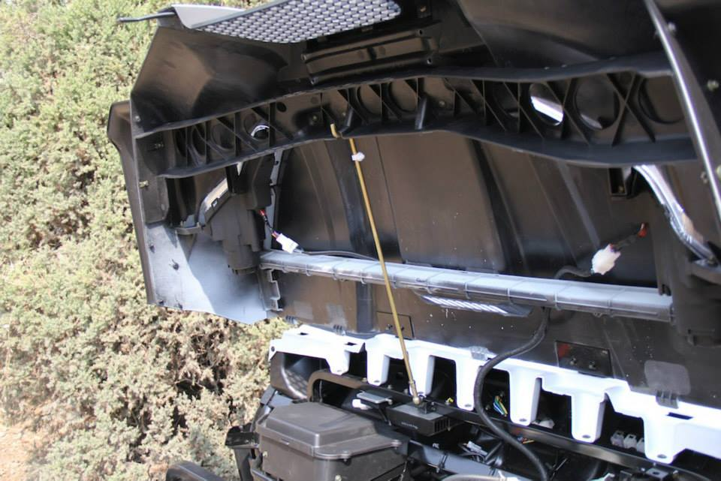

- Latch (x2)

. Hood
To close
Lower the hood slowly to its original position, and then hook the hood latches.
Secure projections on the underside of the hood into slots on the back of the instrument panel. Secure slots on the side of the hood around projections on the frame.
CAUTION:
● Make sure that all cables and wires are in place when closing the hood.
● Do not drive the vehicle with the hood open, unlatched, or removed.

Console
To install
1. Place the console in its original position.
2. Install the parking brake lever boot.
3. Install the seats.
CAUTION:
● Be careful not to pinch the wires or cables when installing the console.
● Make sure that the groove at the bottom of the parking brake lever boot and the drive select lever boot fits securely around the edge of the hole in the console.

Gear Case Oil
Type | Gear oil
Viscosity  (weight) | SAE 80
Suggested oil | Shaft drive oil of original manufacturer or equivalent
Changing Oil
Change the oil with the gear case at normal operating temperature to assure complete and rapid draining.
1. Park the UTV on level ground.
2. Place an oil pan under the oil drain plug (1).
3. Remove the oil filler cap (2) and the drain plug.
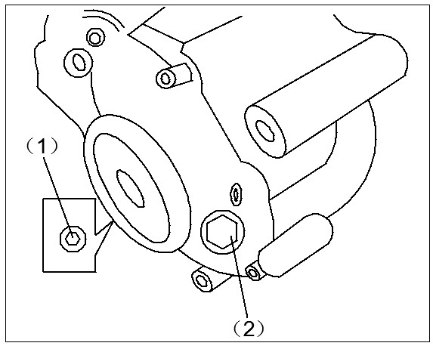

(1) oil drain plug
(2) oil filler cap

Rear knuckle upper and lower pivot lubrication
Lubricate the knuckle upper and lower pivots with a grease gun.
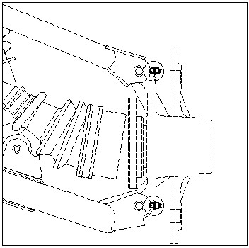

Recommended lubricant:
Lithium-soap-based grease

Steering shaft lubrication
Lubricate the pivot points.

Recommended lubricant:
Lithium-soap-based grease
(all purpose grease)

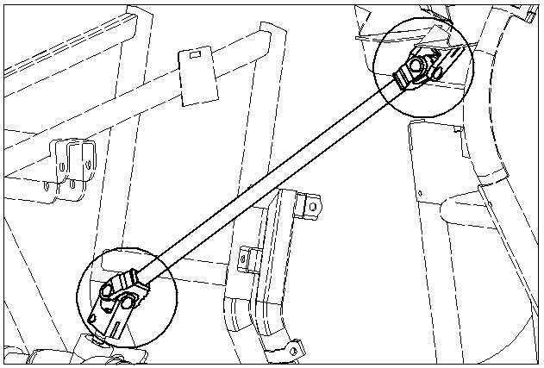

Wheel removal
1. Loosen wheel nuts.
2. Elevate the vehicle.
3. Remove nuts from the wheel.
4. Remove the wheel.
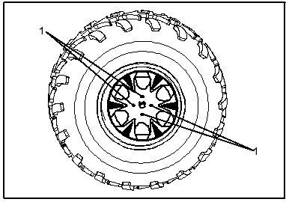

1. Nut (x4)

Wheel installation
1. Install the wheel and nuts.
NOTE:
● The arrow mark on the tire must point the direction toward the wheel turns.
● Tapered nuts are used for both the front and rear wheels. Install the nut with its tapered side towards the wheel.
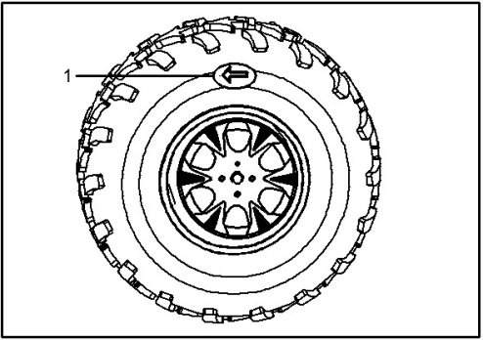

1. Arrow mark

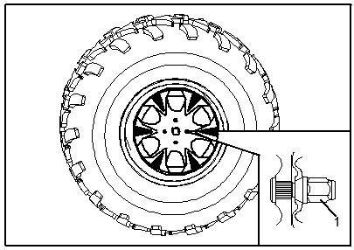

1. Tapered nut

2. Lower the vehicle so that the wheel is on the ground.
3.Tighten the wheel nuts to the specified torque.

Wheel nut to Rear: torque:
Front & Rear:
64 Nm (6.4 m.kgf, 47 ft.lbf)

Battery
This vehicle is equipped with a sealed-type battery. It is not necessary to check the electrolyte or add distilled water in the battery. If the battery seems to have discharged, consult your dealer.
CAUTION:
Do not try to remove the sealing caps of the battery calls. You may damage the battery.
! WARNING
POTENTIAL HAZARD
Failure to handle batteries or battery electrolyte carefully.
WHAT CAN HAPPEN
You could be poisoned or severely burned by the sulfuric acid in battery electrolyte. Batteries produce explosive gases.
HOW TO AVOID THE HAZARD
Avoid contact with skin, eyes or clothing. Always shield eyes when working near batteries. Keep out of reach of children.
Antidote:
EXTERNAL: Flush with water.
INTERNAL: Drink large quantities of water or milk. Follow with milk of magnesia, beaten egg or vegetable oil. Get prompt medical attention.
EYES: Flush with water for 15 minutes and get prompt medical attention. Keep batteries away from sparks, flames. Ventilate when charging or using in a closed space.
Battery maintenance
Battery maintenance
- When the vehicle is not used for a
month or longer, remove the
battery and store it in a cool, dark
place. Completely recharge the
battery before reinstallation.
CAUTION:
The injectors were set at the factory after many tests. If the settings are changed by someone without sufficient technical knowledge, damage and poor engine performance could occur.
- Always make sure the connections are correct when putting the battery back in the vehicle.

! WARNING
Do not connect the negative lead of the jumper cable to the negative terminal of the battery in the vehicle.
● Be especially careful not to:
● Touch the positive lead of the jumper cable to the negative lead.
● Reverse the polarity of the jumper cables when connecting to the batteries. This could cause the battery to explode and severe injury.
Blown Fuses
All of the electrical circuits on your UTV have fuses to protect them from damage caused by excess current flow or short-circuiting.
If something electrical on your UTV stops working, the first thing you should check for is a blown fuse (1).
Check all the fuses before looking elsewhere for another possible cause of the problem. Replace any blown fuses and check component operation.
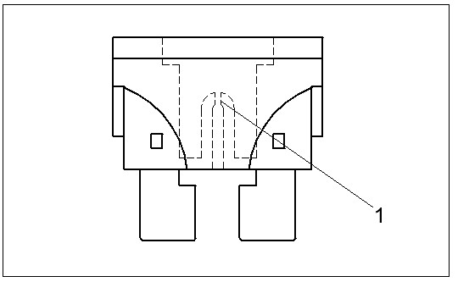

(1) Blown fuse

Fuse replacement
The main fuse and the fuse box are located under the hood. If a fuse is blown, turn off the key switch and install a new fuse of the specified amp. If a fuse is blown, replace it as follows.
1. Remove the fuse box compartment cover by lifting up on the lid.
2. Turn the key to “OFF” and disconnect the damaged electrical circuit.
CAUTION:
To prevent accidental short- circuiting, turn off the main switch when checking or replacing a fuse.
3. Remove the blown fuse, and then install a new fuse of the specified amperage.
Recommended Fuses
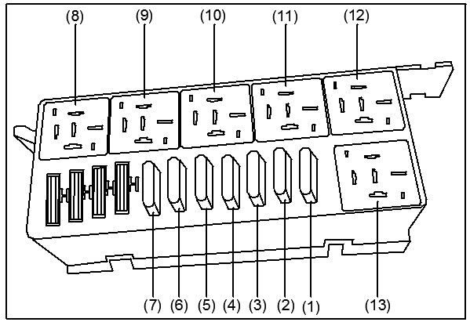

(1) Head lights、2/4 conversion motor、Gear
indicator、Display
(2)Brake light、ECU、Speed sensor、2/4 relay
(3)Fan、Turning light
(4)ECU、EPS
(5)Headlight、Top light
(6)Main relay、Fuel pump
(7)Emergency power supply , Electric lifter ,Horn
NOTE:
Replacing a fuse with one that has a higher rating greatly increases the chance of damage to the electrical system.

Tail/brake light bulb replacement
If a tail/brake light bulb burns out, replace it as follows:
- Remove all push pins that are attached to the rear fender

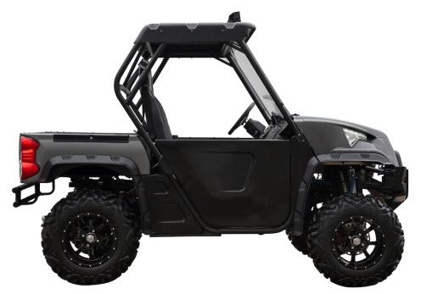

1. Panel A
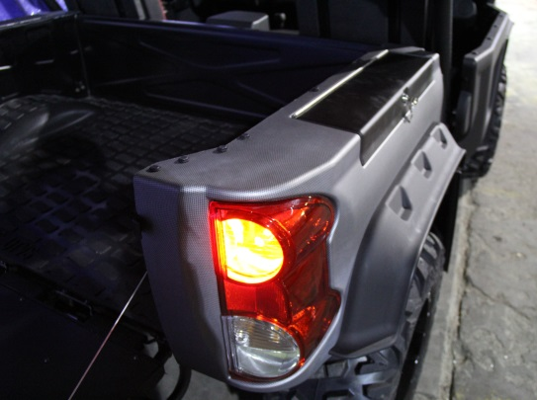

2. Panel B
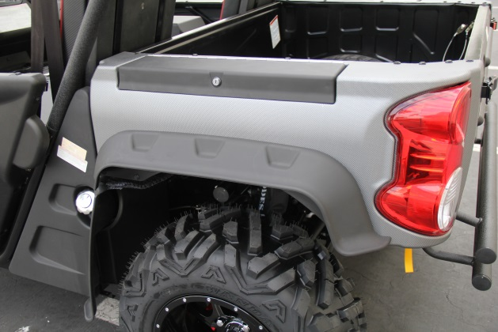

2. Take fender off of dumpbed.
3. Take nuts and bolts off that attach
the taillight to the bed.
4. Take out bulb.
5. Replace bulb and put taillight/ rear fender back together.
Tightening torque:
Panel bolt:
6.5 N.m (0.65 m.kgf, 4.7 ft,lbf)
Troubleshooting
Although vehicles receive a rigid inspection before shipment from the factory, trouble may occur during operation. Any problem in the fuel, compression, or ignition systems can cause poor starting and loss of power. See the troubleshooting chart for more information. If your vehicle requires any repair, take it to an authorized dealer. The technicians at a dealership have the tools, knowledge, and experience to properly service your vehicle. Use only genuine parts on your vehicle. Imitation parts may look similar, but they are often inferior.
Consequently, they have a shorter service life and can lead to expensive
! WARNING
POTENTIAL HAZARD
Checking the fuel system while smoking or near an open flame.
WHAT CAN HAPPEN
Fuel can ignite or explode, causing
severe injury or property damage.
HOW TO AVOID THE HAZARD
Do not smoke when checking the fuel system. Make sure there are no open flames or sparks in the area, including pilot lights from water heaters or furnaces.

repair bills!

Troubleshooting charts
Starting problems or poor engine performance
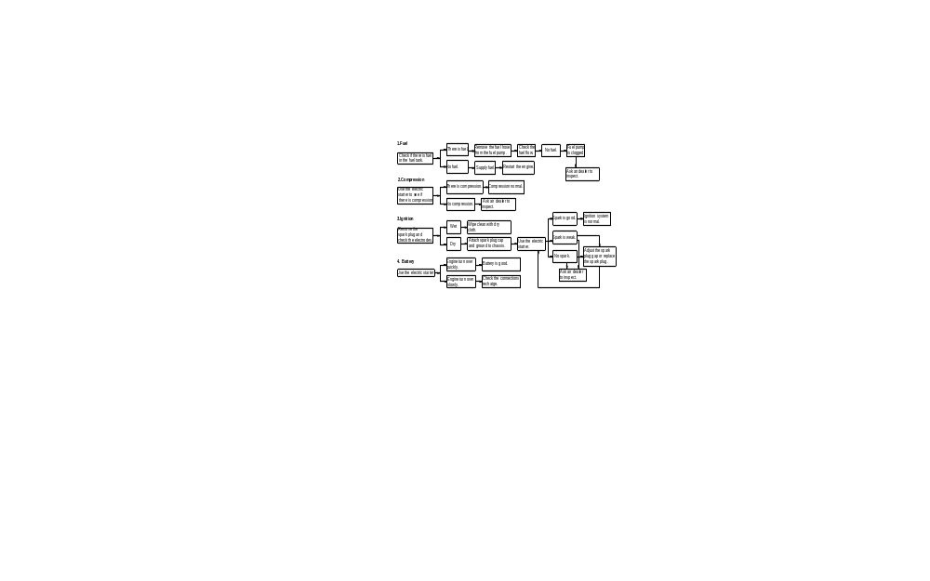

Engine overheating
! WARNING
POTENTIAL HAZARD
Removing the radiator cap when the engine and radiator are still hot.
WHAT CAN HAPPEN
You can be burned by hot fluid and steam blown out under pressure.
HOW TO AVOID THE HAZARD
Wait for the engine to cool before removing the radiator cap. Always use a thick rag over the cap. Allow any remaining pressure to escape before completely removing the cap.

See Next Page for Chart
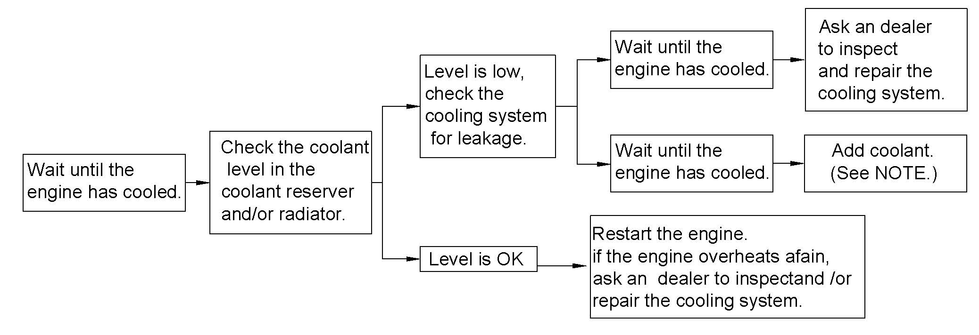

NOTE:
If it is difficult to get the recommended coolant, tap water can be temporarily used, provided that it is changed to the recommended coolant as soon as possible.

Cleaning and storage
CLEANING
Frequent, thorough cleaning of your vehicle will not only enhance its appearance, but also improve its general performance and extend the useful life of many components.
1. Before cleaning the vehicle:
A. Block off the end of the exhaust pipe to prevent water entry using a plastic bag and a strong rubber band.
B. Make sure the spark plug and all filler caps are properly installed.
2. If the engine case is excessively greasy, apply degreaser with a paintbrush. Do not apply degreaser to the wheel axles.
3. Rinse the dirt and degreaser off with a garden hose. High-pressure water is not necessary.
CAUTION:
Excessive water pressure may cause water seepage and deterioration of water seepage and deterioration of wheel bearings，brakes, transmission seals and electrical devices. Many expensive repair bills have resulted from high-pressure detergent applications such as those available in coin-operated car washers.
4. Once the majority of the dirt has been hosed off, wash all surfaces
with warm water and mild, detergent- type soap. An old toothbrush may be handy for hard-to-reach places.
5. Rinse the vehicle off immediately with clean water and dry all surfaces with a clean towel or soft absorbent cloth.
6. Clean the seats with vinyl upholstery cleaner to keep the cover pliable and glossy.
7. Automotive type wax may be applied to all painted and chrome plated surfaces. Avoid combination cleaner-waxes. Many contain abrasive chemicals that could scratch the paint or protective finish. When finished, start the engine and let it idle for several minutes.
! WARNING
POTENTIAL HAZARD
Operation with wet brakes after washing.
WHAT CAN HAPPEN
Wet brakes may have reduced stopping ability, increasing the chance of an accident.
HOW TO AVOID THE HAZARD
Test the brakes after washing. Apply the brakes several times at slow speeds to let friction dry out the linings.

STORAGE
Long-term storage (60 days or more) of your vehicle will require preventive procedures to guard against deterioration. After thoroughly cleaning the vehicle, prepare for storage as follows:
1. Fill the fuel tank with fresh fuel and add the specified amount of fuel stabilizer and conditioner or an equivalent product. Operate treated fuel through the fuel system.
2. Drain the fuel from the carburetor float chamber into a clean container by loosening the drain bolt; this will help prevent fuel deposit build up. Pour the drained fuel onto the fuel tank.
Specified amount:
1 oz of stabilizer to each gallon of fuel or(7.5 cc of stabilizer to each liter of fuel)

NOTE:
Use of fuel stabilizer and conditioner eliminates the need to drain the fuel system. Consult an authorized dealer if the fuel system needs to be drained instead.

3. Remove the spark plug and pour about one tablespoon of SAE 10W30 or 20W40 motor oil in the spark plug. Ground the spark plug wire and turn the engine over several times to coat the cylinder wall with oil.
4. Lubricate all control cables.
5. Raise the frame so that all wheels are off the ground.
6. Tie a plastic bag over the exhaust pipe outlet to prevent moisture from entering.
7. If storing in a humid or salt-air
atmosphere, coat all exposed metal
surfaces with a light film of oil. Do
not apply oil to any rubber parts or the seat covers.
8. Remove the battery and charge it. Store it in a dry place and recharge it once a month. Do not store the battery in an excessively warm or cold place (less than 0 Degrees C (30 Degrees F) or more than 30 Degrees C (90 Degrees F)).
NOTE:
Make any necessary repairs before storing the vehicle.

NOISE REGULATION
TAMPERING WITH NOISE CONTROL SYSTEM PROHIBITED:
Federal law prohibits the following acts: (1) The removal or rendering inoperative by any person other than for purposes of maintenance, repair, or replacement of any device or element of design incorporated into any new vehicle for the purpose of noise control prior to its sale or delivery to the ultimate purchaser or (2) the use of the vehicle after such device or element of design has been removed or rendered inoperative by any person.
“AMONG THOSE ACTS PRESUMED TO CONSTITUTE TAMPERING ARE THE ACTS LISTED BELOW.”
These acts include tampering with the following systems; i.e.; modification, removal, etc.
Exhaust system | Muffler  Exhaust pipe  Silencer
Intake system | Air cleaner case  Air cleaner element  Intake duct

ENGINE
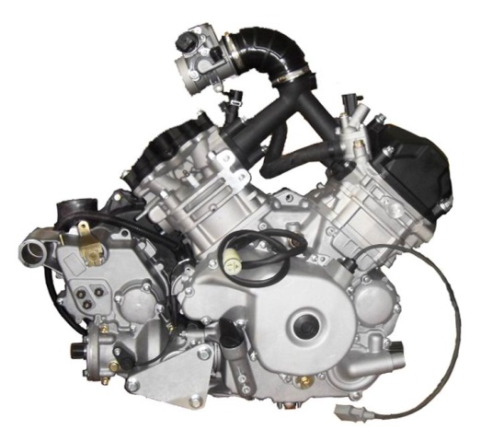

Engine Oil

Recommended Oil
Use 4-stroke mineral-based engine oil that meets or exceeds the requirements for API service classification SM, SL or SJ. Always check the API service label certification on the oil container; it must contain at least one of the above standards.

Oil Viscosity
SAE 5W30 mineral-based oil is recommended for all seasons.
However, during the hottest days of the summer, the XP-S 10W40 mineral oil can be used.
NOTE: For improved overall performance and all season applications, use XP-S 5W40 synthetic oil.

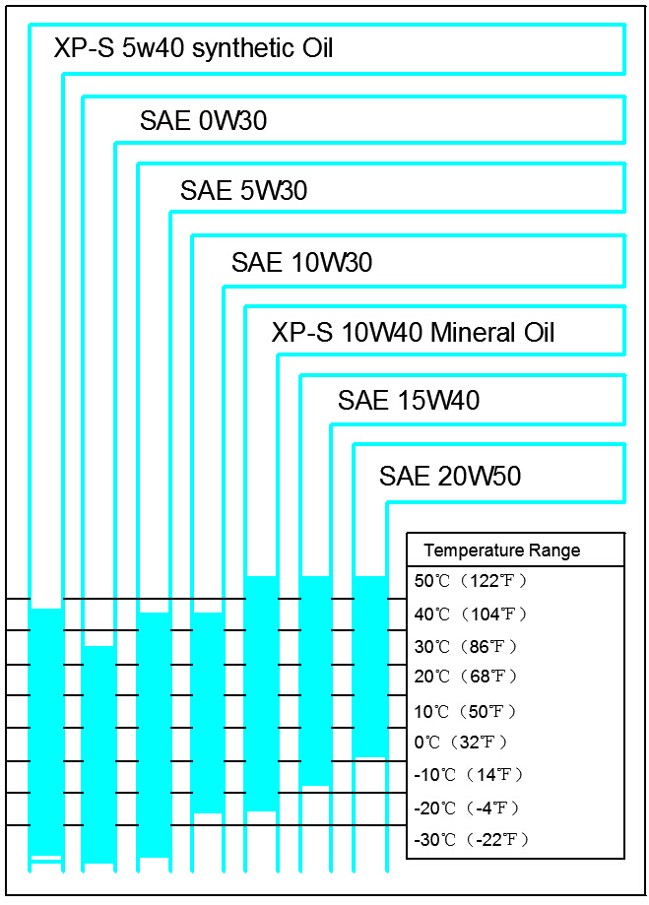

Oil Level
CAUTION: Check level frequently and refill if necessary. Do not overfill. Operating the engine with an improper level may severely damage engine. Wipe off any spillage.
With vehicle on a level surface and engine cold, not running, check the oil level as follows:
- Unscrew dipstick then remove it and wipe clean.
- Reinstall dipstick, screw in it completely.

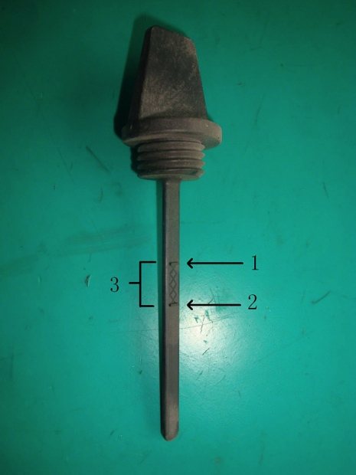

TYPICAL
- Full
- Add
- Operating range

- Remove and check oil level. It
should be near or equal to the upper mark.
To add oil, remove the dipstick. Place a funnel into the dipstick tube to avoid spillage.
Add a small amount of recommended oil and recheck oil level.
Repeat the above procedures until oil level reaches the dipstick’s upper mark.

Do not overfill.
Properly tighten dipstick.

Oil Change and Oil Filter Replacement
Oil and oil filter are to be replaced at the same time. Oil change should be done with a warm engine.

! WARNING
The engine oil can be very hot. In order to avoid potential burns, do not remove the engine drain plug or the filter cover if the engine is hot. Wait until engine oil is warm.

Ensure vehicle is on a level surface.
Remove dipstick.
Clean the oil drain plug area.
Place a drain pan under the oil drain plug area.
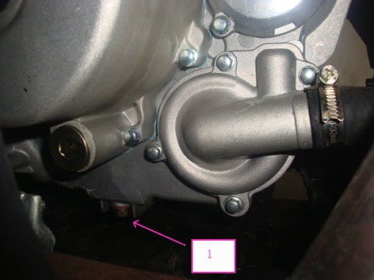
Unscrew oil drain plug.

1. Oil drain plug
Allow enough time for oil to flow out of the oil filter.
Unscrew the oil filter cover.
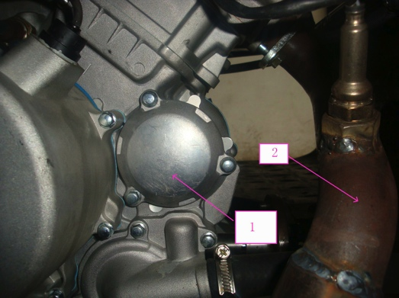

- Oil filter cover
- Exhaust pipe

Remove old filter and replace with new oil filter.
Check the cover O-ring and change it if necessary
.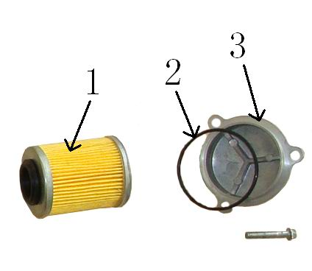
- Oil filter
- O-ring
- Oil filter cover

Screw oil filter cover in place.
Wipe out any oil spillage on engine.
Change gasket on oil drain plug. Clean gasket area on engine and oil drain plug then reinstall plug. Refill engine at proper level with the recommended oil. Refer to SPECIFICATIONS for capacity.
Start engine and let it idle for a few minutes. Ensure oil filter area and oil drain plug areas are not leaking.
Stop engine. Wait a while to allow oil to flow down to the crankcase then check oil level. Refill as necessary. Dispose of oil as per your local environmental regulations.

Engine Coolant
Recommended coolant
Always use ethylene-glycol antifreeze containing corrosion inhibitors specifically for internal combustion aluminum engine. Cooling system must be filled with premixed coolant.
Coolant level
! WARNING
Check coolant level when engine is cold. Never add coolant in cooling system when engine is hot.

Remove access panel.
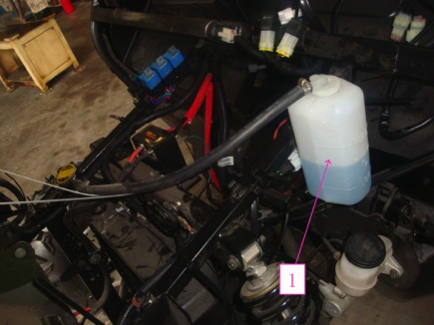

- Coolant reservoir
With vehicle on a level surface, liquid should be between MIN and MAX marked on the coolant reservoir.
NOTE:
When checking level at temperature lower than 20 Degrees C, it may be slightly lower than MIN mark. Add coolant up to MAX mark if required. Use a funnel to avoid spillage.

Do not overfill.
Properly reinstall and tighten filler cap and reinstall access panel. If coolant is added in the coolant reservoir, check the radiator level too. Add coolant if necessary.
! WARNING
In order to avoid getting burned, do not remove the radiator cap if the engine is hot.
NOTE:
A cooling system that frequently requires coolant is the indication of leaks or engine problems. See an authorized dealer.

Coolant Replacement
! WARNING
In order to avoid potential burns, do not remove the radiator cap or loosen the coolant drain plug if the engine is hot.
Open the front access panel and remove the radiator cap.
Unscrew the coolant drain plug and drain the coolant into a suitable container.
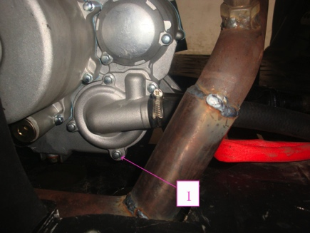

- Coolant drain plug
NOTE:
Do not unscrew the coolant drain plug completely.
Unscrew the bleeding screw on the top of the thermostat housing.
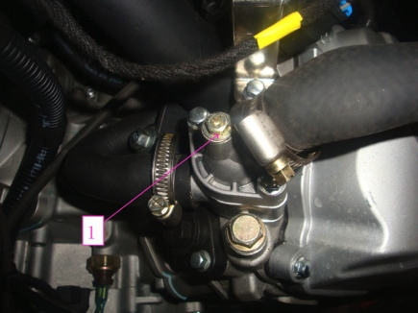

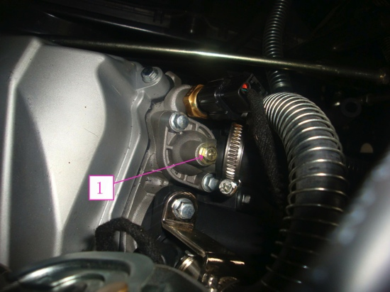
Drain the system completely and reinstall the coolant drain plug.

Pinch hose between radiator and the thermostat housing with a large pincher or an equivalent.
CAUTION:
Do not use vise-grip pliers to pinch hose.

Fill the radiator until the coolant comes out by the thermostat-housing hole.
Complete the radiator filling.
Check the level in the coolant reservoir and refill if necessary.
Run engine at an idle with the radiator cap off. Slowly add coolant if necessary. When the engine reaches normal operating temperature, press the throttle level two or three times; then add coolant if required.
Install radiator cap. Inspect all connections for leaks and check coolant level in the reservoir.

Air Filter
Removal
CAUTION:
Never remove or modify any component in the air filter housing. Poor engine performance or damage can occur. The engine is calibrated to operate specifically with these components.

Remove access panel.
Loosen clamp and remove air filter.
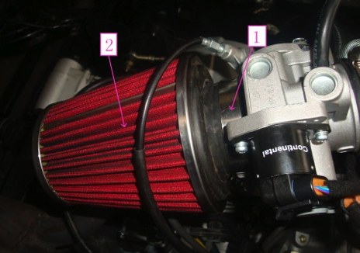

- Clamp
- Air filter
Cleaning
Pour cleaning solution or an equivalent into a bucket. Put the filter in to soak.
While filter soaks, clean inside the air filter housing.
Rinse the filter with warm water until all cleaning solution disappears.
Then, let the filter dry completely.
Installation
Properly reinstall removed parts in the reverse order of their removal.

Drive Belt
See an authorized ODES dealer to check the width and the condition of drive belt.
CVT Cover Drain Screw
Any time you suspect that water has entered the CVT cover, drain the CVT housing by removing the drain screw.

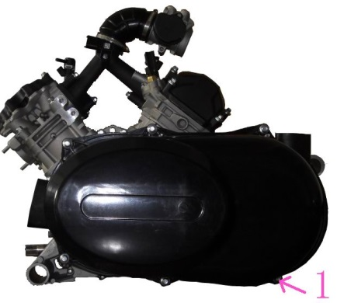

Valve Adjustment
See an authorized ODES dealer for valve adjustment.
Insufficient clearance will cause loss of power and possibly damage the valves. Excessive clearance will cause noise.
Spark Arrester
The muffler must be periodically purged of accumulated carbon.
! WARNING
Never run engine in an enclosed area. Never perform this operation immediately after the engine has been running because the exhaust system is very hot. Make sure that there are no combustible materials in the area. Wear eye protection and gloves. Never stand behind the vehicle while purging the exhaust system. Respect all applicable laws an regulations.

Select a well-ventilated area and make sure the muffler is cool.
Place transmission on PARK position.
Remove the cleanout plug of the muffler.
Block the end of the muffler with a shop rag and start the engine.
Momentarily increase engine RPM several times to purge accumulated carbon out of the muffler.
Stop engine and allow muffler to cool.
Reinstall the cleanout plug.
Radiator
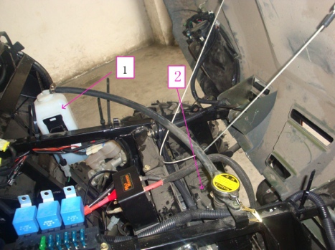
Periodically check the radiator area for cleanliness.

- Coolant reservoir
- Radiator
Inspect radiating fins. They must be clean, free of mud, dirt, leaves and any other deposit that would prevent the radiator to cool properly.
Remove as much deposits as you can with your hands. If water is available in proximity, try rinsing the radiating fans.
If available, use a garden hose to rinse the radiating fins.
! WARNING
Never clean the radiator with your hands when it is hot. Let the radiator cool down before cleaning.

CAUTION:
Be careful not to damage the radiating fins when cleaning. Do not use any object/tool that could damage the parts to allow efficient cooling. When hosing use low-pressure water only. See an authorized ODES dealer to check the performance of the cooling system.
Gearbox Oil
Recommended Oil
Use XP-S chain case oil or an equivalent.
CAUTION:
Do not use other types of oil when servicing. Do not mix with other types of oil.

Gearbox Oil Level
CAUTION:
Check level and refill if necessary. Do not overfill. Operating the gearbox with an improper level may severely damage gearbox. Wipe off any spillage.
Place the vehicle on a level surface.
Select NEUTRAL position then apply parking brake.
Remove gearbox oil level plug to check level.

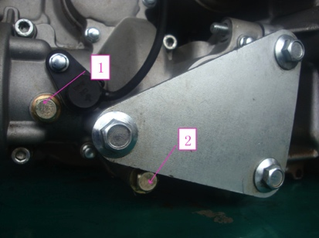

- Oil level plug
- Oil drain plug
The oil should be level with the bottom of the oil level bole. Refill as required until gearbox oil level flows through oil level hole.
Gearbox Oil Change
Place the vehicle on a level surface.
Clean drain plug area and oil level plug then remove the gearbox drain plug.
NOTE: To completely drain the gearbox, place a jack under the left footrest and tilt the vehicle toward the right side. When the gearbox is empty, install the drain plug and replace the vehicle on the ground.
Refill gearbox, using XP-S chain case oil or an equivalent.
CAUTION:
Use recommended types of oil only, when servicing. Do not mix with other types of oil.
The oil should be level with the bottom of the oil level hole. Refill as required through the breathe pipe, until gearbox oil level flows through oil level hole.
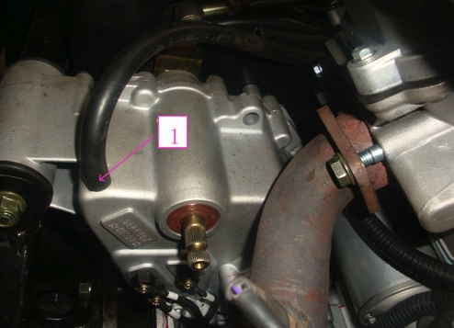

1. Breathe Pipe
Reinstall oil level plug.

MAINTENANCE CHART
Maintenance is very important. If you are not familiar with safe service practices and adjustment procedures, see your authorized dealer.
PERIODIC MAINTENANCE CHART
A:ADJUST | INITIAL INSPECTION 5 HOURS OR 100 MILES
C:CLEAN | (The initial maintenance is very important and must not to be neglected)
I:INSPECT |  | 25 HOURS OR 500 MILES
L:LUBRICATE |  |  | 50 HOURS OR 1000 MILES
R:REPLACE |  |  |  | 100 HOURS OR 2000 MILES OR 1 YEAR
 |  |  |  |  | 150 HOURS OR 3000 MILES OR 2 YEARS
 |  |  |  |  |  | TO BE PERFOMED BY
PART/TASK |  |  |  |  |  |  | LEGEND

ENGINE
Engine oil level (2) |  | EVERY RIDE |  |  |  |  |  |  |  |  |  | Customer | (2) Pre-ride  inspection  item.  (3) Every 100 hours, check coolant strength  (4) More often under severe use such as dusty areas, sand, snow, wet or muddy conditions.
Engine oil and filter |  | R |  |  |  | R |  |  |  |  |  | Customer
Valve adjustment |  | I.A |  |  |  |  |  |  | I.A |  |  | Dealer
Engine mount fasteners |  | I |  |  |  |  |  |  | I |  |  | Dealer
Air filter (2) |  |  |  | C(4) |  | R(4) |  |  |  |  |  | Customer
Exhaust system |  | I |  |  |  |  |  |  | I |  |  | Dealer
Spark arrester |  |  |  |  |  |  |  |  | C |  |  | Customer
Condition of engine seals |  | I |  |  |  |  |  |  | I |  |  | Dealer
Coolant (2) |  | I |  |  |  |  |  |  | I (3) | R |  | Customer
Cooling system pressure test |  | I |  |  |  |  |  |  |  | I |  | Dealer
Radiator condition/ cleanliness (radiator fins) (4) |  | I |  |  |  | I |  |  |  |  |  | Customer
ENGINE MANAGEMENT SYSTEM
A:ADJUST | INITIAL INSPECTION 10 HOURS OR 200 MILES
C:CLEAN | (The initial maintenance is very important and must not to be neglected)
I:INSPECT |  | 25 HOURS OR 500 MILES
L:LUBRICATE |  |  | 50 HOURS OR 1000 MILES
R:REPLACE |  |  |  |  | 100 HOURS OR 2000 MILES OR 1 YEAR
 |  |  |  |  |  |  | 150 HOURS OR 3000 MILES OR 2 YEAR
 |  |  |  |  |  |  |  | TO BE PERFOMED BY
PART/TASK |  |  |  |  |  |  |  |  |  | LEGEND
SUSPENSION
Trailing arms |  |  |  |  | I |  |  | Dealer |  |  | ——
Trailing arm bearings | I |  |  |  |  |  | I | Dealer
Shock absorbers |  |  | I |  |  |  |  | Dealer
A-arms |  |  | I,L |  |  |  |  | Customer
Ball joints |  | I |  |  |  |  |  | Dealer

BRAKES
Brake fluid (front and rear)(2) | I | I |  |  | R | Customer / Dealer | (2) Pre-ride inspection item.  (4) More often under severe use such as dusty areas, sand, snow, wet or muddy conditions.
Brake pads |  | I(4) |  |  |  | Customer
Brake system (discs, hoses, etc.) |  |  |  | I |  | Customer
BODY /FRAME
Engine compartment | I,C |  | I,C |  |  | Customer | (4) More often under severe use such as dusty areas, sand, snow, wet or muddy conditions.
Frame |  |  |  | I |  | Dealer
Chassis fasteners |  |  | I |  |  | Customer
Seat fasteners | EVERY RIDE |  |  |  |  | Customer

FAULT CODES
A fault code is an indication that a glitch or malfunction is detected by the self-diagnostic system.
Read fault code
Remove the upper cover of engine hood and look for the harness connector of fault diagnosis tester beside the ECU.
Unplug the protector, connect the fault diagnosis tester by special data cable.
Turn on the fault diagnosis tester and read fault code.
CODE |  | FAULT
P0031 |  | Cylinder 1 heater of oxygen sensor is existing short circuit to ground
P0032 |  | Cylinder 1 heater of oxygen sensor is existing short circuit to power supply
P0037 |  | Cylinder 2 heater of oxygen sensor is existing short circuit to ground
P0038 |  | Cylinder 2 heater of oxygen sensor is existing short circuit to power supply
P0107 |  | Intake manifold pressure sensor is existing short circuit to ground or disconnecting
P0108 |  | Intake manifold pressure sensor is existing short circuit power supply
P0112 |  | Intake air temperature sensor is existing short circuit to ground or disconnecting
P0113 |  | Intake air temperature sensor is existing short circuit power supply
P0117 |  | Coolant temperature sensor is existing short circuit to ground
P0118 |  | Coolant temperature sensor is existing short circuit to power supply or disconnecting
P0122 |  | Throttle position sensor is existing short circuit to ground or disconnecting
P0123 |  | Throttle position sensor is existing short circuit to power supply
P0131 |  | Cylinder 1 oxygen sensor is existing short circuit to ground
 | P0132 |  | Cylinder 1 oxygen sensor is existing short circuit to power supply
 | P0137 |  | Cylinder 2 oxygen sensor is existing short circuit to ground
 | P0138 |  | Cylinder 2 oxygen sensor is existing short circuit to power supply
 | P0201 |  | Injector of cylinder 1 is damaged
 | P0202 |  | Injector of cylinder 2 is damaged
 | P0230 |  | Fuel pump is existing short circuit to ground or disconnecting
 | P0232 |  | Fuel pump is existing short circuit power supply
 | P0336 |  | Signal of crankshaft position sensor is disturbed
 | P0337 |  | No signal of crankshaft position sensor
 | P0351 |  | Ignition coil of cylinder 1 is damaged
 | P0352 |  | Ignition coil of cylinder 2 is damaged
 | P0505 |  | Air bypass valve is damaged
 | P0562 |  | Power supply voltage is too high
 | P0563 |  | Power supply voltage is too poor
 | P0650 |  | Engine indicator lamp is damaged
 | P1693 |  | Signal of speed gauge is existing short circuit to ground
 | P1694 |  | Signal of speed gauge is existing short circuit to power supply

Clear fault code
After correcting the problem that caused the fault code, clear fault code by the fault diagnosis tester.

Warranty Statement.
U.S.A. EPA Emissions Limited Warranty
This All Terrain Vehicle (ATV) and Off Highway Motorcycle (OFMC) emissions limited warranty is in addition to the ODES UTVS LLC standard limited warranty for All Terrain Vehicles.

ODES UTVS LLC warrants that this vehicle are; (1) designed, built, and equipped to conform at the time of initial sale with the requirements of 40 CFR 1051.120(b).And, (2) free from defects in materials and workmanship that may keep it from meeting these requirements.

The emissions warranty period for this vehicle begins on the date the vehicle is delivered to the original retail purchaser, vehicles with displacement of 975cc and (under), warranty period shall be 2 ½ years or 5,000 km, whichever comes first.

This emission – related warranty covers components whose failure would increase an engine’s emissions, including electronic controls, fuel injection, exhaust—gas recirculation, after treatment, or any other system utilized in this vehicle to control emissions. Replacing or repairing other components not covered by this emissions warranty or the standard warranty is the responsibility of the owner; including the parts, labor and other costs associated with recommended maintenance.

The exclusive remedy for breach of this limited warranty shall be, at the exclusive option of ODES UTVS LLC, repair or replacement of any defective materials, components or products. THE REMEDIES SET FORTH IN THIS LIMITED WARRANTY ARE THE ONLY REMEDIES AVAILABLE TO ANY PERSON FOR BREACH OF THIS WARRANTY. ODES UTVS LLC SHALL HAVE NO LIABILITY TO ANY PERSON FOR INCIDENTAL, CONSEQUENTIAL OR
SPECIAL DAMAGES OF ANY DESCRIPTION, WHETHER ARISING OUT OF EXPRESS OR IMPLIED WARRANTY OR ANY OTHER CONTRACT, NEGLIGENCE OR OTHERTORT OR OTHER WISE.

ALL IMPLIED WARRANTIES (INCLUDING BUT NOT LIMITED TO ANY IMPLIED WARRANTEIES OF MERCHANTABILITY AND FITNESS FOR A PARTICULAR PURPOSE) ARE LIMITED IN DURATION TO THE WARRANTY PERIOD DESCRIBED HEREIN. ODES
UTVS LLC DISCLAIMS ALL EXPRESS WARRANTIES NOT STATED IN THIS WARRANTY. Some states do not allow limitations on how long an implied warranty lasts, so the above limitation may not apply if it is inconsistent with the controlling state law.
This limited warranty excludes failures not caused by a defect in material or workmanship. This limited warranty does not cover damage due to accidents, abuse or improper handling, maintenance or use. This limited warranty also does not cover any engine that has been structurally altered, or any engine that has been used in racing competition. This limited warranty also does not cover physical damage, corrosion or defects caused by fire, explosions to other similar causes beyond the control of ODES UTVS LLC.

If you have any questions regarding your warranty rights and responsibilities, you should contact the ODES UTVS LLC Warranty Department at 888-572-8428

SPECIFICATIONS
Model |  | Two door | Four door
Dimensions | Overall length | 3030mm | 3830mm
Dimensions | Overall width | 1730mm | 1730mm
Dimensions | Overall height | 1950mm | 1950mm
Dimensions | Seat height | 850mm | 850mm
Dimensions | Wheelbase | 1900mm | 2700mm
Dimensions | Ground clearance | 285mm | 285mm
Basic weight | With oil and full fuel tank | 658kg | 765kg
Final gear  case oil | Type | Wet tank lubrication, oil filters can be changed
Final gear  case oil | Quantity | 2.2 L
Fuel | Type | Unleaded gasoline only 93# or higher
Fuel | Fuel tank capacity | 24.5 L
Spark plug | Type/manufacturer | DCPR8E / NGK
Transmission | Transmission type | Four speed & one reverse
Transmission | Operation | Manual

Model |  | UTV800
Chassis | Frame type | Steel tube frame
Chassis | Caster angle | 5.0 °
Chassis | Trail | 26.0mm（1.02in）
Tire | Type | Tubeless
Tire | Size Front | 27×9–14
Tire | Size Rear | 27×11–14
Brakes | System | Front and rear unified
Brakes | Type Front | Dual disc brake
Brakes | Type Rear | Single disc brake
Brakes | Operation | Foot operation
Suspension | Front suspension | Double wishbone
Suspension | Rear suspension | Double wishbone
Shock absorber | Front shock absorber | Coil spring / oil damper
Shock absorber | Rear shock absorber | Coil spring / oil damper
Wheel travel | Front wheel travel | 185.0 mm ( 7.28 in )
Wheel travel | Rear wheel travel | 185.0 mm ( 7.28 in )

Model | UTV800
Engine model | 2V91MW
Type | Two-cylinder, overhead cam (SOHC), water cooling,
Cylinder diameter | 91 mm
Piston stroke | 61.5 mm
Compression ratio | 10.3：1
Displacement | 7.97 L
Maximum torque | 73N.m/5000 RPM
Idle speed | 1250rpm

